**Project 1:**

**Kinematic Analysis of ARISTO Robot using Robo Analyzer**

ABSTRACT

This paper presents an in-depth examination of the kinematics of the ARISTO Robot, leveraging the sophisticated capabilities of Robo Analyzer software. Renowned for its adaptability and precision across a spectrum of applications, the ARISTO Robot undergoes meticulous analysis using advanced simulation tools to elucidate its motion characteristics and optimize operational efficiency.

Commencing with an elucidation of the ARISTO Robot's mechanical configuration and degrees of freedom, the study lays the groundwork for subsequent analytical procedures. Utilizing Robo Analyzer, essential kinematic parameters such as joint velocities, accelerations, and positions are meticulously computed, facilitating a comprehensive evaluation of the robot's motion capabilities.

A pivotal focus of the analysis encompasses both forward and inverse kinematic analyses of the ARISTO Robot within the context of real-time simulation of its manipulators. A primary advantage offered by Robo Analyzer is its capacity to conduct simulations under user-defined conditions in real-time, thereby enabling precise point-to-point control of the robot. This feature enhances the versatility and efficiency of the analysis, ensuring that simulations closely mirror actual operational scenarios.

Moreover, the paper delves into the seamless integration of Robo Analyzer with real-time control systems, facilitating the smooth translation of simulation outcomes into practical applications. This integration augments the performance of the ARISTO Robot by incorporating sophisticated feedback mechanisms and adaptive control strategies, thereby optimizing its functionality across diverse operational environments.

In summary, the utilization of Robo Analyzer in conjunction with rigorous kinematic analysis offers invaluable insights into the ARISTO Robot's motion dynamics, empowering stakeholders to enhance operational efficiency, reliability, and adaptability in various industrial and research domains.

Introduction to ARISTO Robot

The ARISTO Robot is a sophisticated 6-axis articulated robotic arm designed to handle various tasks with precision and efficiency. With a payload capacity of 2.5kg, it is capable of performing a wide range of industrial, training, and research applications under the constant power supply of 230V AC, 50/60 HZ, 5A. Manufactured according to industry standards, the ARISTO Robot is renowned for its reliability and versatility in diverse settings.

In addition to its robust mechanical design and high payload capacity, the ARISTO Robot's kinematic structure is defined by Denavit-Hartenberg (DH) parameters, which systematically characterize its geometry and motion capabilities. These parameters, including link lengths (a), link offsets (d), joint angles (θ), and twist angles (α), enable precise computation of the robot's forward and inverse kinematics. By integrating these DH parameters into its kinematic model, the ARISTO Robot can perform intricate motion control and navigate complex workspaces with ease, enhancing its effectiveness in various applications.

In industrial contexts, the ARISTO Robot excels in tasks such as material handling, assembly, and welding, leveraging its precise movements and high payload capacity to enhance productivity and operational efficiency. Its advanced kinematics enable seamless integration into automated production lines, where it can perform repetitive tasks with unparalleled accuracy.

Moreover, the ARISTO Robot serves as a valuable educational tool in training environments, offering an intuitive interface and user-friendly programming software for teaching robotics principles and programming techniques. Learners of all levels can engage in hands-on experimentation and skill development, fostering a deeper understanding of robotics concepts.

In research applications, the ARISTO Robot provides a platform for studying various aspects of robotic manipulation, control algorithms, and human-robot interaction. Its flexibility and programmability allow researchers to customize experiments and explore new avenues in robotics research, contributing to advancements in the field.

Equipped with pneumatic or electrical grippers, the ARISTO Robot can grasp and manipulate objects of different shapes, sizes, and materials, further extending its capabilities and enhancing its adaptability to specific task requirements. This versatility enables seamless integration into diverse workflows, making it a valuable asset in enhancing productivity and advancing the field of robotics.

Overall, the ARISTO Robot stands as a testament to innovation in robotics technology, offering a reliable and efficient solution for industrial automation, training, and research endeavors. Its multifaceted capabilities, coupled with its compatibility with various gripper options and DH parameters, make it a versatile tool for addressing the evolving needs of modern industries and research institutions.

Introduction to RoboAnalyzer

RoboAnalyzer is a cutting-edge 3D model-based software designed to facilitate the teaching and learning of robotics concepts. Developed within the Mechatronics Lab at the Department of Mechanical Engineering, IIT Delhi, India, it has evolved into a comprehensive tool for enhancing understanding in the field of robotics.

The inception of RoboAnalyzer dates back to 2009, spearheaded by Prof. S.K. Saha. It was conceived to support the educational objectives outlined in his seminal work, "Introduction to Robotics," published by Tata McGraw Hill. This initiative aimed to bridge the gap between theoretical concepts and practical application, particularly in conveying complex mathematical principles like forward and inverse kinematics inherent in robotics studies.

One of the primary challenges encountered by both students and instructors in robotics education is the abstract nature of mathematical concepts, especially when dealing with 3D transformations and Denavit-Hartenberg (DH) parameters commonly used to represent industrial robots. RoboAnalyzer addresses these challenges by providing intuitive visualizations and simulations, enabling users to grasp the underlying physics of robotic motion before delving into the intricacies of mathematical analysis.

RoboAnalyzer boasts an array of features tailored to support learning and teaching objectives:

Serial Manipulator Simulation: Users can model serial manipulators with both prismatic and revolute joints, allowing for the representation of diverse robotic systems.

DH Parameters Input: The software accepts DH parameters as input, generating corresponding 3D models of robotic structures.

Forward and Inverse Kinematics: RoboAnalyzer facilitates the computation of forward and inverse kinematics, enabling users to understand and analyze the motion of robotic systems.

Inverse and Forward Dynamics: Users can explore inverse and forward dynamics, gaining insights into the forces and torques involved in robotic motion.

Simulation and Visualization: Animated simulations with trace visualization of end-effector motion provide a dynamic representation of robotic movements.

Integration with MATLAB and MS Excel: Seamless integration with MATLAB's Robotics Toolbox and MS Excel enhances the software's functionality, enabling advanced analysis and simulation capabilities.

Virtual Robot Module: Access to a library of 17+ CAD models of industrial robots allows for practical experimentation and exploration of robotic systems.

Save and Open Robot Models: Users can save and retrieve robot models, facilitating continuity in experimentation and analysis.

For the current project, the focus will be on two key features: Forward Kinematics and Inverse Kinematics. These capabilities enable users to compute and analyze the position and orientation of robotic end-effectors, laying the groundwork for deeper exploration into robotic motion planning and control. With RoboAnalyzer intuitive interface and comprehensive feature set, users can embark on a journey of discovery and mastery in the field of robotics education and research.

To start working on the app Robo Analyzer we need to have a PC of minimum specifications of:

* Processor: Atleast 1.5 GHz
* RAM: Atleast 512 MB
* Operating System: Windows XP, Windows Vista, Windows 7, 8, 8.1, 10,11
* Dependencies: Microsoft .Net 2.0 framework / .Net 4.5 framework (for HTM Module)

We can start our analysis only if the specifications of our pc is equivalent or better than the specified minimum requirement.

Before Starting our analysis, we should know how to open and function the RoboAnalyzer.

To Access the features of RoboAnalyzer 1st we need to download the app from the site: <http://www.roboanalyzer.com/>

After going to the site and downloading the RoboAnalyzer .zip file right click on the file and click extract

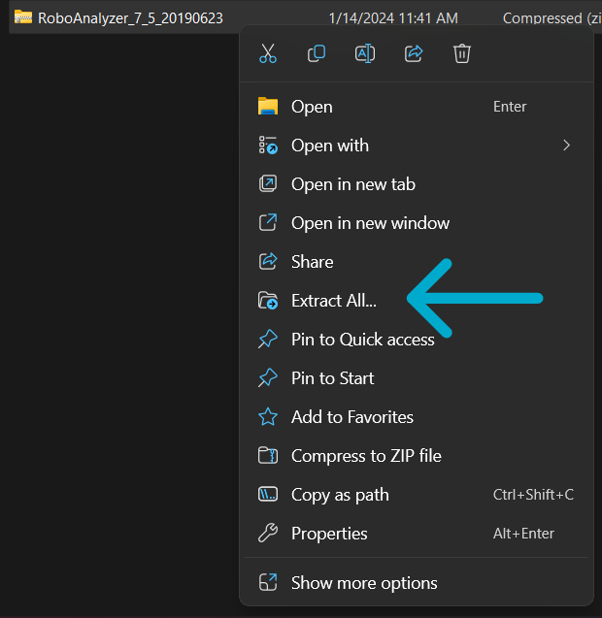

After extracting the file download open the extracted file and click on the app named RoboAnalyzer.

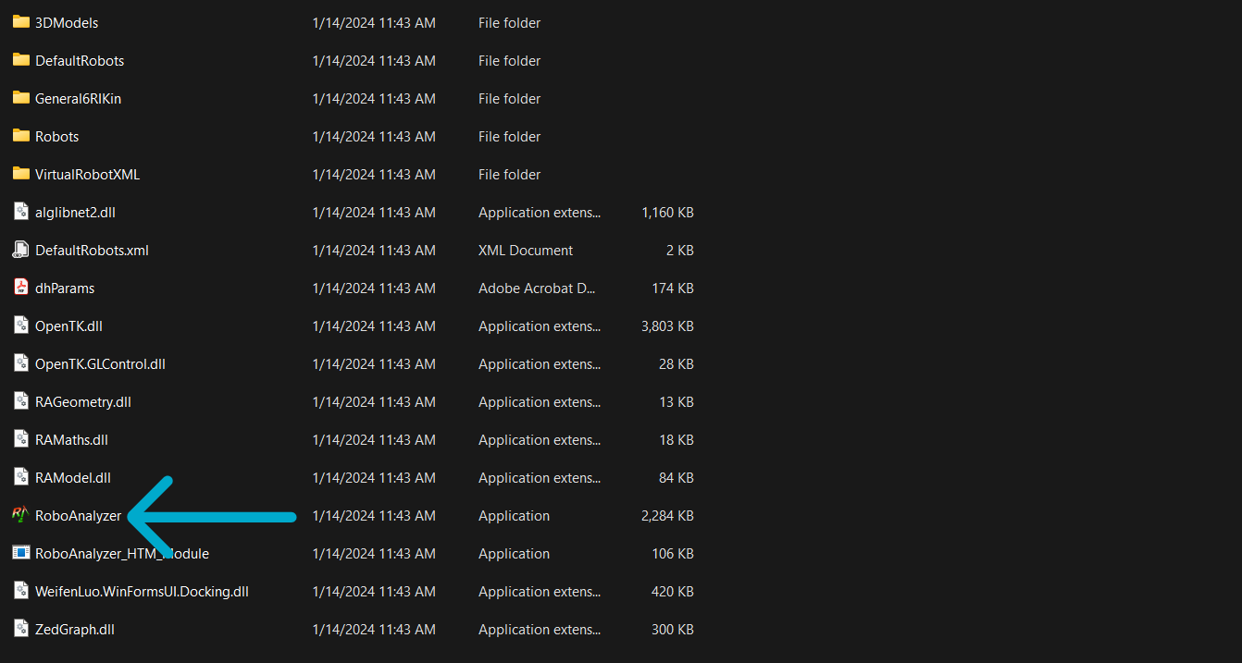

Once you have clicked on the app, the following window will open.

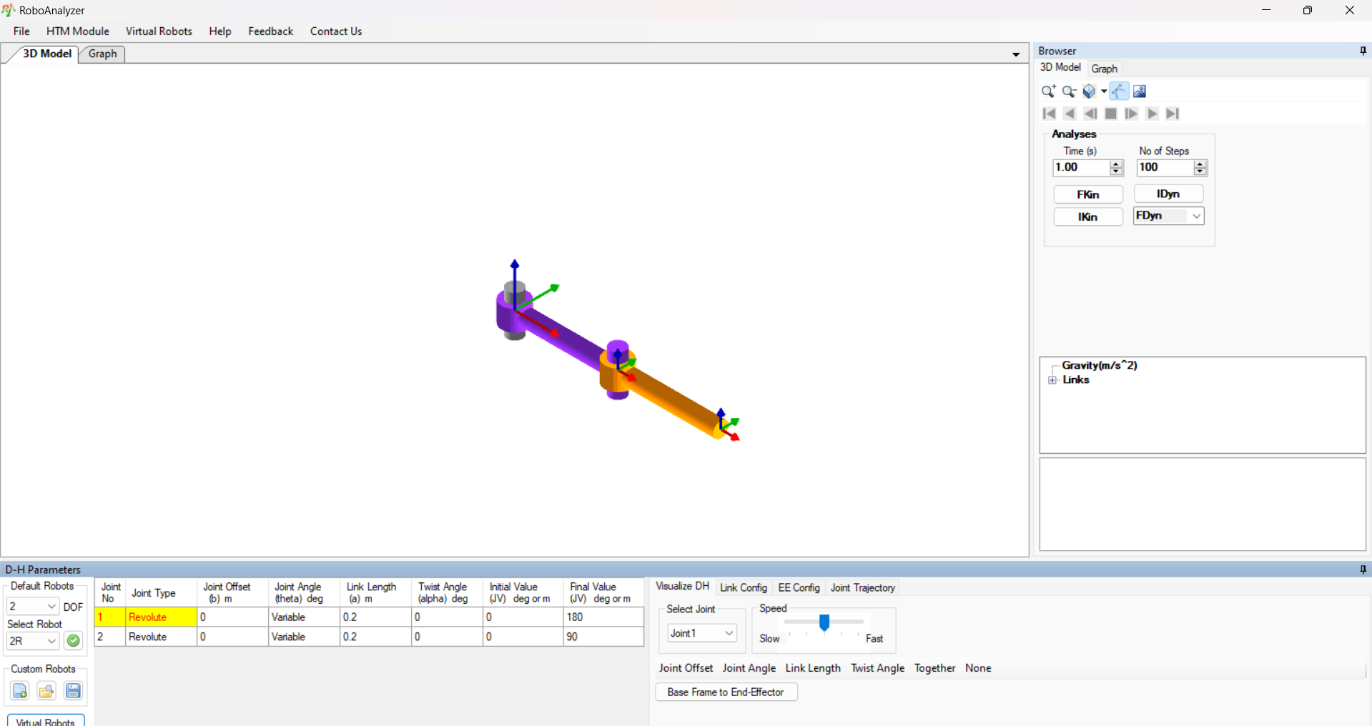

Now you have successfully opened the app RoboAnalyzer, to access the ARISTO Robot’s 3d module on the screen go to the DOF option under the D-H Parameters and select the number 6 from DOF.

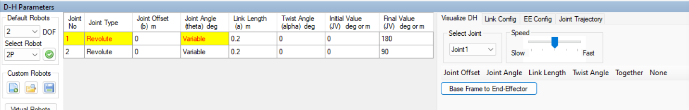

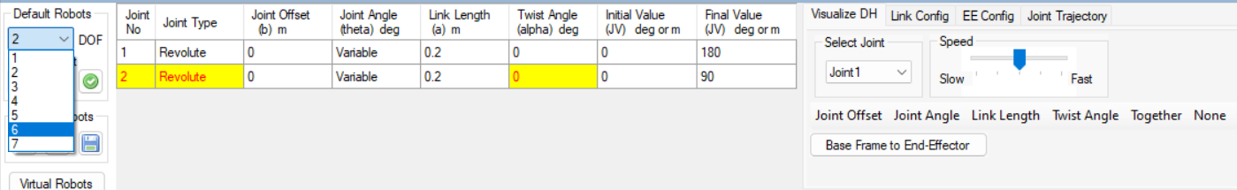

After selecting the option of 6 go to the select robot option under the DOF and select ARISTO.

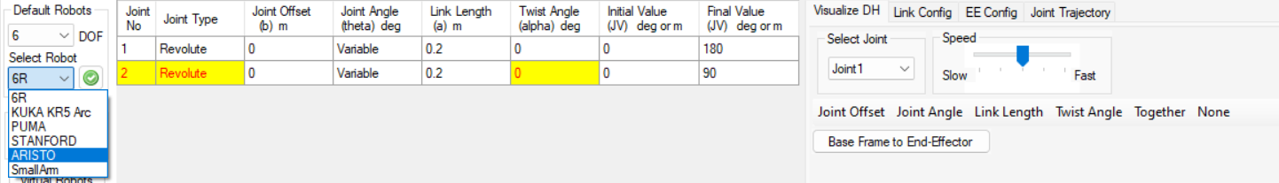

After Clicking the ARISTO option, you won’t see any changes until you click the green tick button beside the select robot option.

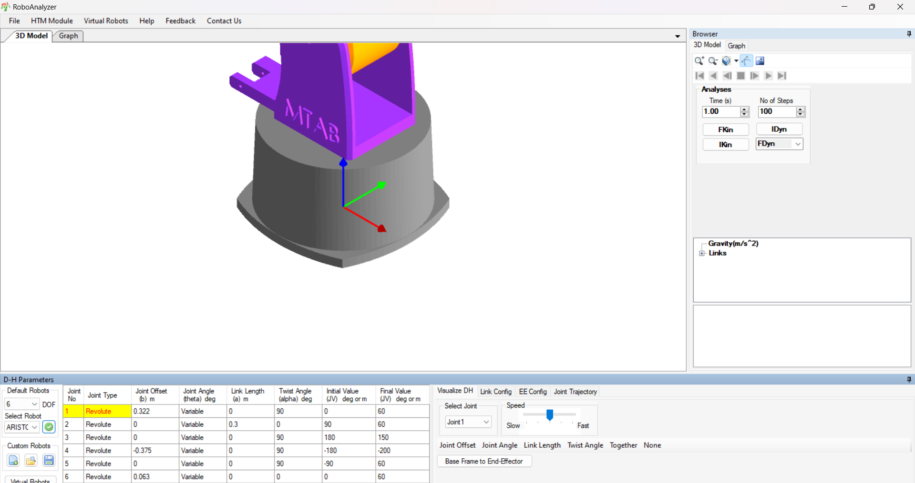

Now you have accessed the ARISTO Robot pre-loaded in the RoboAnalyzer Software. To see the whole robot in the software we need to zoom out on the screen by either using the scroll wheel on the action screen or by clicking the zoom out/zoom in button under the 3D model browser on the right action tab of the software.

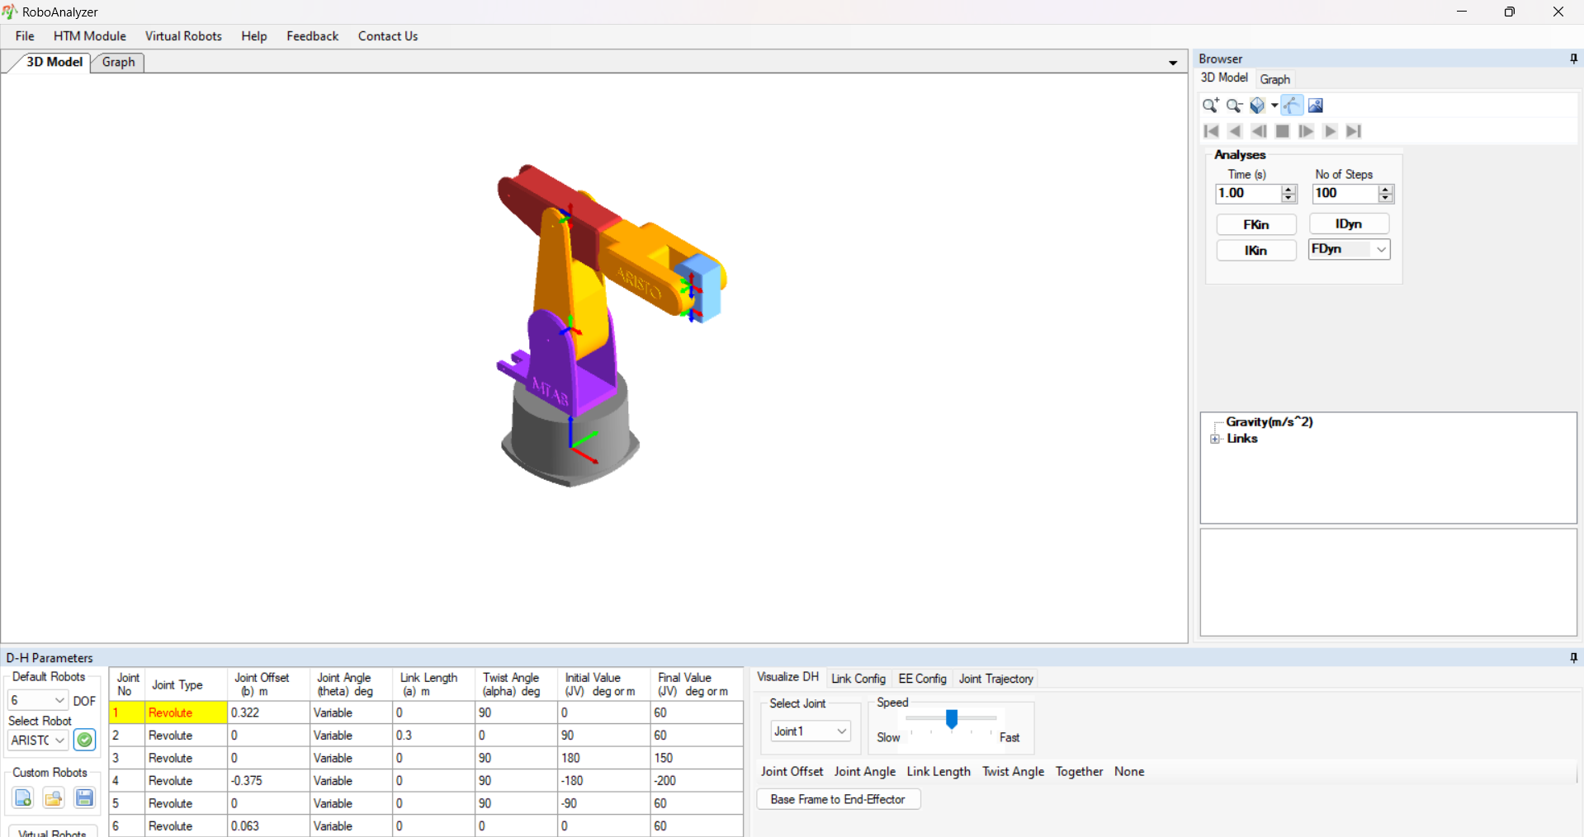

Now that you have zoomed out you can see the whole ARISTO Robot in the software, you can move approximately by using the mouse keys or Select View option beside the zoom out option.

After this we will explain the components which will be used in analysis of Forward and Reverse Kinematics of ARISTO Robot.

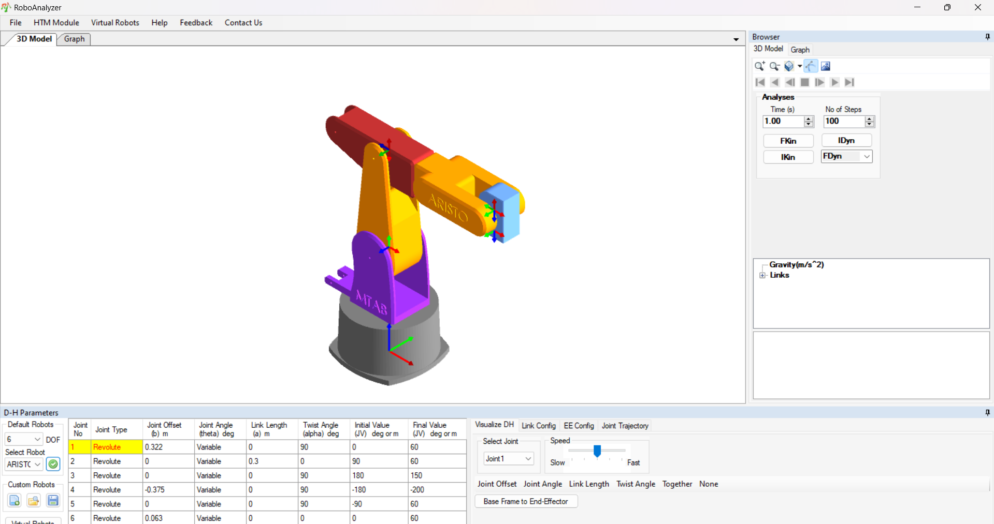

The above image shows us the whole view of the RoboAnalyzer from this we will be showing the action tabs and their functions.

D-H Parameters

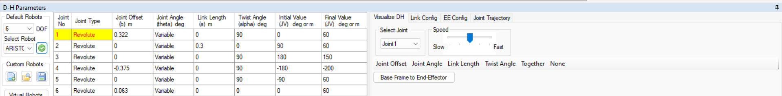

The D-H Parameters section has three sub sections-

* The default robot – This lets us choose the default robot which will be showed us on the screen.

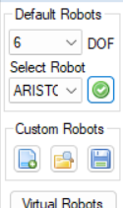

* The joint parameters – This is the table which lets us set the joint parameters of the robot before starting the defined motion.

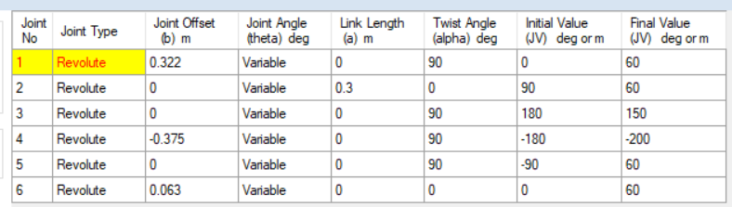

This tab includes:

1. Joint Type – This shows the type of joint used in the robot.
2. Joint Offset – Length of intersection of common normal on joint axis.
3. Joint Angle – Angle between the orthogonal projections of the common normal to the plane normal to the joint axis.
4. Link Length – Measured as the distance between the common normal to the axis.
5. Twist Angle – The angle between the orthogonal projections of the joint axes onto a plane normal to the common normal.
6. Initial Value – It is the initial angle of the joint before the movement from point one to another is done.
7. Final Value – It is the final angle of the joint after the movement of the joint from one point to another is done.

* The Visualize D-H Tab – This tab visualizes the D-H parameters defined in the D-H parameter Table

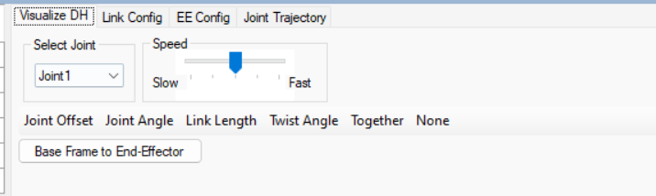

* Link Config Tab – This tab is used to find the position of a single joint.

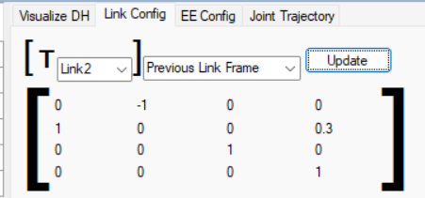

* EE Config – This tab is used to find the position of the End Effector of the ARISTO Robot.

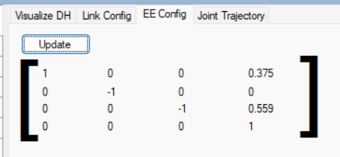

* Joint Trajectory Tab – This is the tab used to define the type of trajectory the ARISTO robot will use.

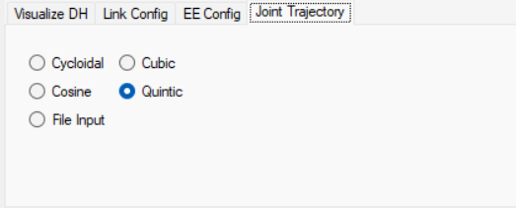

Browser

The Browser Tab lets us see the Analysis of the ARISTO Robot using Forward Dynamics, Inverse Dynamics, Forward Kinematics and Inverse Kinematics. Adding to this this tab lets us see the graphical values of the ARISTO Robot. The graphical value and visualization will be explained further down.

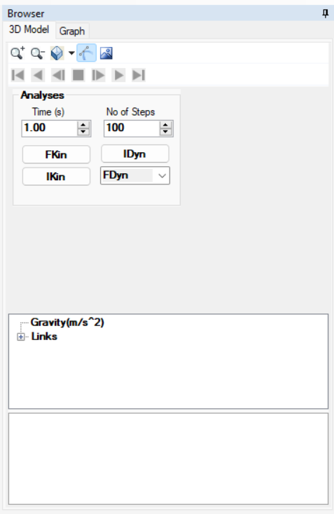 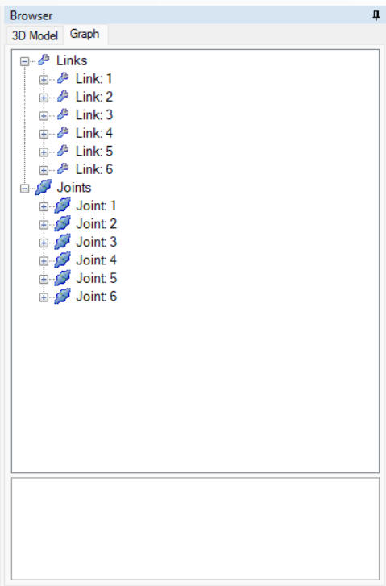

The changes by the user in the Browser tab and D-H parameter tab (both of the 3D model and graph section) is showed on the screen.

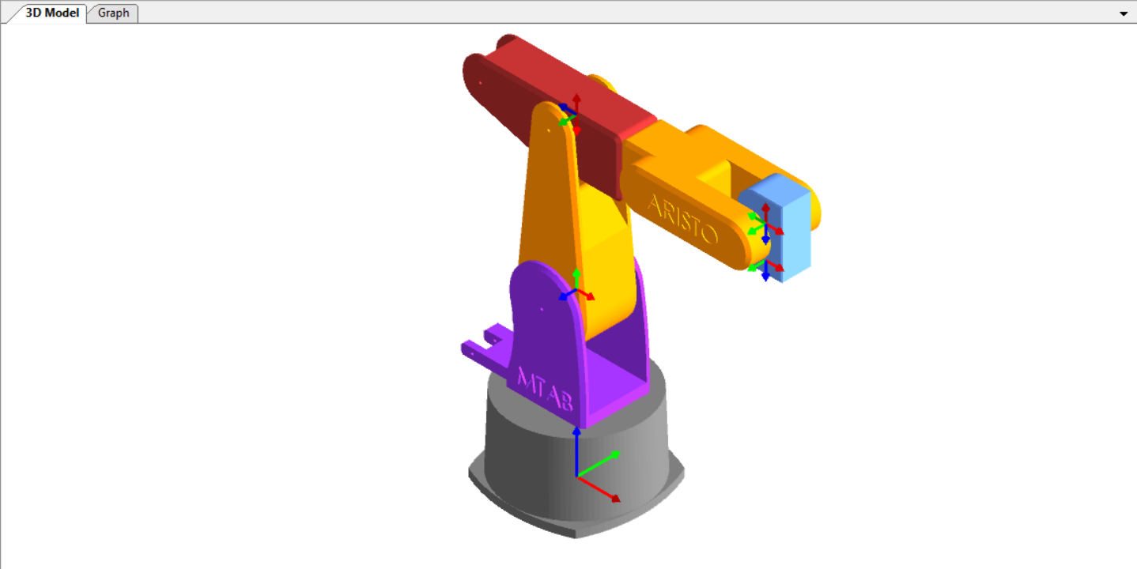

This is the screen that not only shows the ARISTO Robot but also shows us the visualization of the movement when we click the play button in the browser section after selecting either Forward or Inverse Kinematics.

In this same screen there is another option to visualize the link movements based on graphical values, this option is called the Graph which is beside the 3D Model tab.

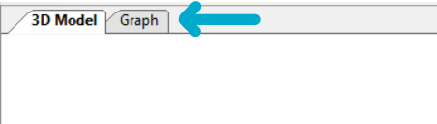

Once clicked on this tab the following will be showed on the screen.

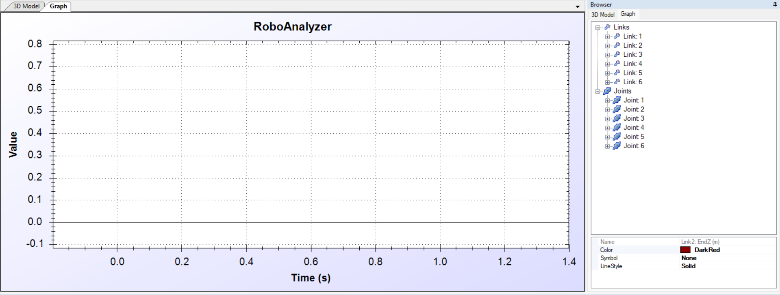

This screen shows us the graphical visualization of the ARISTO Robot only when we set the kinematics of the robot. Without selectin the kinematics the graph tab will look as follows.

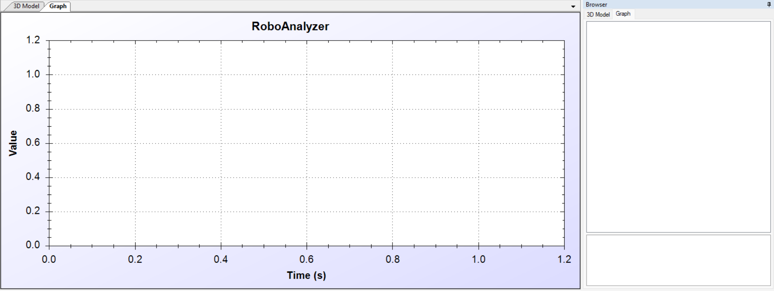

The graph option for the links will once be showcased if we select the kinematics of the ARISTO Robot.

The Graph Option on the right-hand side is kept for the user to select which link motion of the ARISTO robot will be visible graphically.

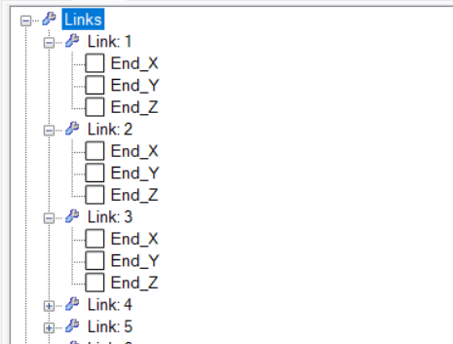

The above image shows us the expansion of the link option and the checkbox once checked will graphically show the velocity of that link on the following axis.

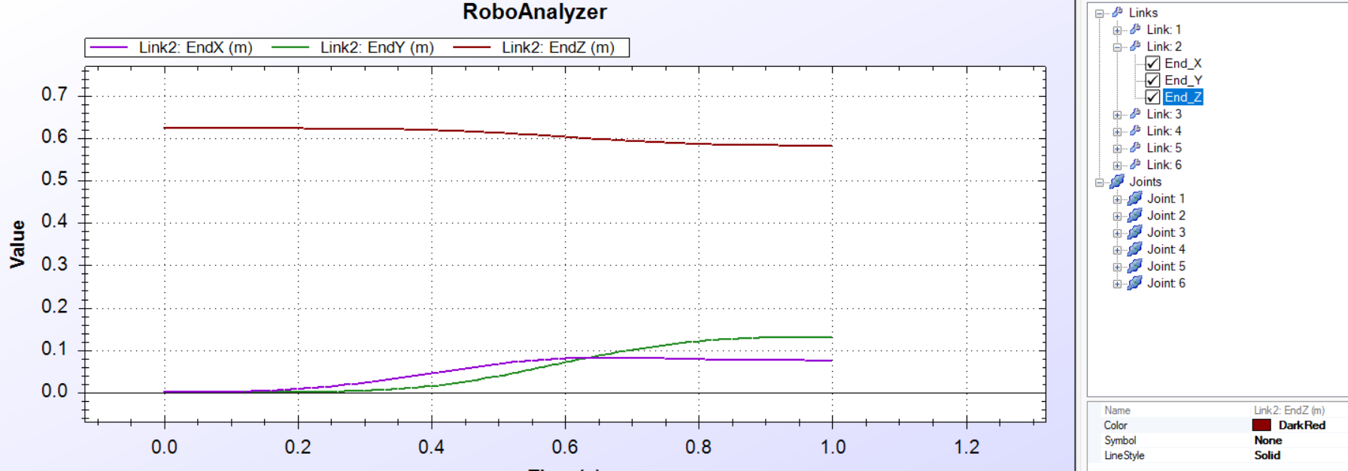

For Example, if we select all the X, Y, and Z parameters of the Link 2 we can see the velocity of that link in that axis.

The values on graph can change on the bases on the values set in the D-H parameters section.

Now that we have covered all the features and functionality in RoboAnalyzer we can start with the analysis of our Forward and Inverse Kinematics.

KINEMATIC ANALYSIS OF ARISTO Robot using Robo-Analyzer

Once you have acquired all the knowledge regarding the app RoboAnalyzer and the ARISTO Robot we can start with acquiring the knowledge of Forward and Reverse Kinematics.

Forward Kinematics:

Forward kinematics is a fundamental concept in robotics that involves determining the position and orientation of the end-effector (such as a gripper or tool) of a robotic system given the joint angles or displacements. In other words, forward kinematics enables us to calculate where the end-effector is located and oriented in space based on the robot's joint configurations.

For a robotic manipulator with multiple joints, forward kinematics involves computing the transformation from the robot's base frame to its end-effector frame. This transformation accounts for the effects of each joint's motion on the end-effector's position and orientation relative to the robot's base.

The Denavit-Hartenberg (DH) parameters are commonly used to represent the kinematic structure of robotic manipulators and facilitate forward kinematics calculations. These parameters define the geometric and kinematic properties of each joint and link in the robot, allowing us to systematically derive the transformation matrix from one coordinate frame to another.

Once the transformation matrix is obtained, it can be used to determine the position and orientation of the end-effector relative to the robot's base frame. This information is crucial for tasks such as motion planning, trajectory generation, and robot programming, as it enables engineers to predict and control the robot's motion accurately and efficiently.

Overall, forward kinematics plays a vital role in understanding and analyzing the motion capabilities of robotic systems, forming the basis for more advanced concepts such as inverse kinematics and motion control. By accurately predicting the end-effector's position and orientation for given joint configurations, engineers can design and optimize robotic systems for various applications in industrial automation, manufacturing, and beyond.

Reverse Kinematics:

Inverse kinematics, often referred to as reverse kinematics, is a crucial concept in robotics that involves determining the joint angles or displacements required to achieve a desired position and orientation of the end-effector (such as a gripper or tool) of a robotic system. In other words, inverse kinematics allows us to calculate the joint configurations necessary to move the end-effector to a specific location and orientation in space.

For robotic manipulators with multiple joints, inverse kinematics involves solving a set of equations that relate the end-effector's position and orientation to the joint angles or displacements. These equations take into account the kinematic constraints and geometric properties of the robot, such as joint limits, joint ranges of motion, and link lengths.

Solving the inverse kinematics problem is often more challenging than forward kinematics, as it requires finding solutions that satisfy both the desired end-effector pose and the constraints of the robotic system. In many cases, there may be multiple solutions or no solutions at all, depending on the robot's kinematic structure and the desired end-effector pose.

Inverse kinematics is essential for tasks such as robot control, motion planning, and manipulation, as it enables engineers to specify desired end-effector poses and compute the corresponding joint configurations to achieve those poses. By determining the joint angles required for motion control, inverse kinematics plays a crucial role in programming and controlling robotic systems to perform tasks accurately and efficiently.

Overall, inverse kinematics is a fundamental concept in robotics that complements forward kinematics, providing a means to translate desired end-effector poses into actionable joint configurations. By solving the inverse kinematics problem, engineers can design and control robotic systems for a wide range of applications, from industrial automation and manufacturing to medical robotics and beyond.

Now that we have acquired the knowledge on Forward and Reverse Kinematics, we can start with its analysis using RoboAnalyzer.

Firstly, we will open the RoboAnalyzer app from the folder you have downloaded the app in,

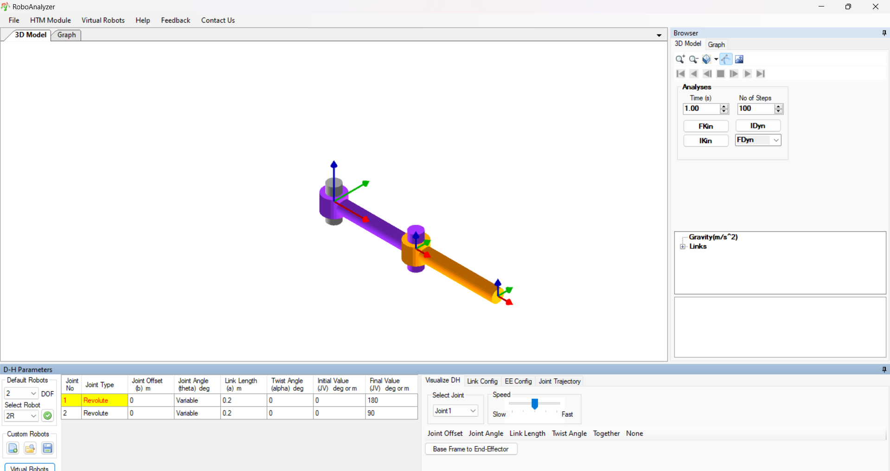

Now that we have opened the software, we will open the ARISTO robot on the screen using the Default Robot option.

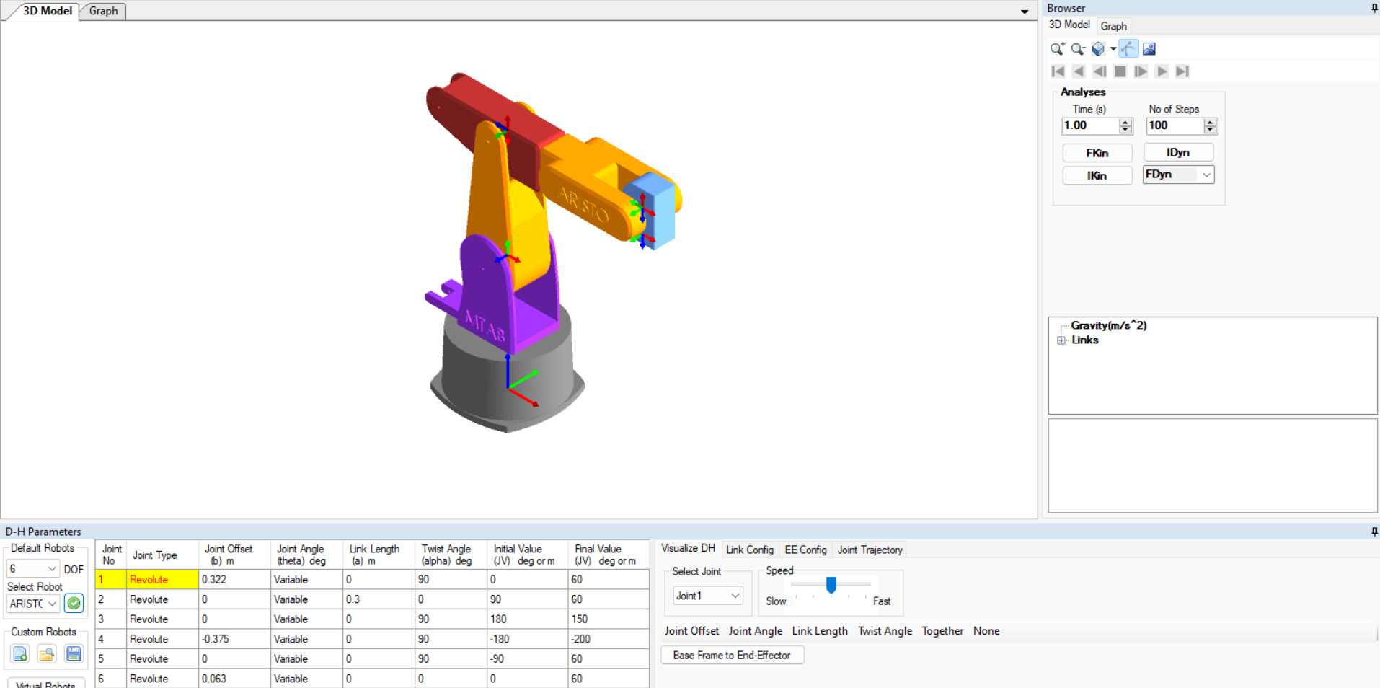

First, we will be performing the Forward Kinematics.

Analysis Forward Kinematics

To perform the Forward kinematics of the ARISTO robot we need to know four values, the link offset, joint offset, link length and twist angle.

Let’s consider the Default values of the ARISTO Robot which were pre-loaded in the software, although one can change the values by edition the values on the D-H parameter table

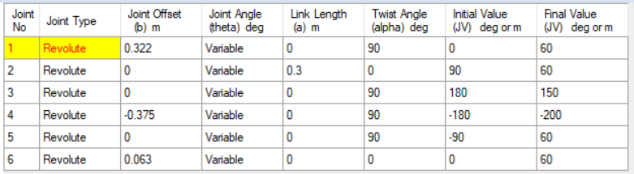

This is the default value of our ARISTO Robot.

NOTE– Without these values input by the user once cannot simulate a Forward kinematics.

The end effector position can be found on updating that matrix in the EE config tab.

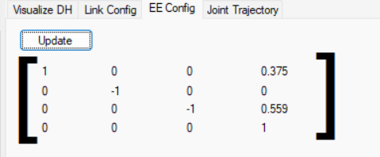

This shows the initial value of the End Effector before starting our Forward Kinematics Simulation.

During the simulation clicking update on the EE Config will show the position and translatory position of the End Effector at that instant.

Now that we have set the d-H parameters and the initial position of the End Effector, we can load the simulation by clicking on FKin button on the Analysis tab under the 3D model tab on the right of the screen.

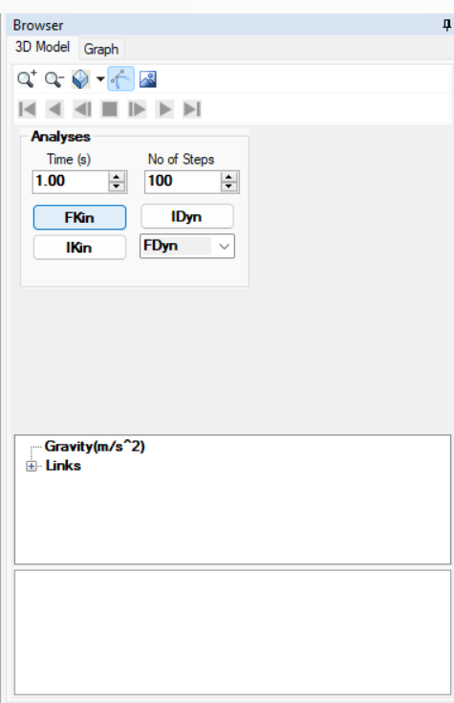 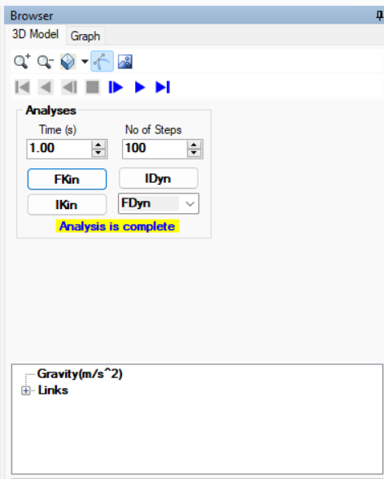

After clicking on the FKin there will be a text popup informing the user Analysis is complete. This will not only enable us to start the simulation by clicking the blue play buttion avove the Analysis tab, but also will help us analyse the movement of the ARISTO Robot.

By changing the time and the number of steps we can change the seep of movement of the Robot.

After clicking the play button we can see the following.

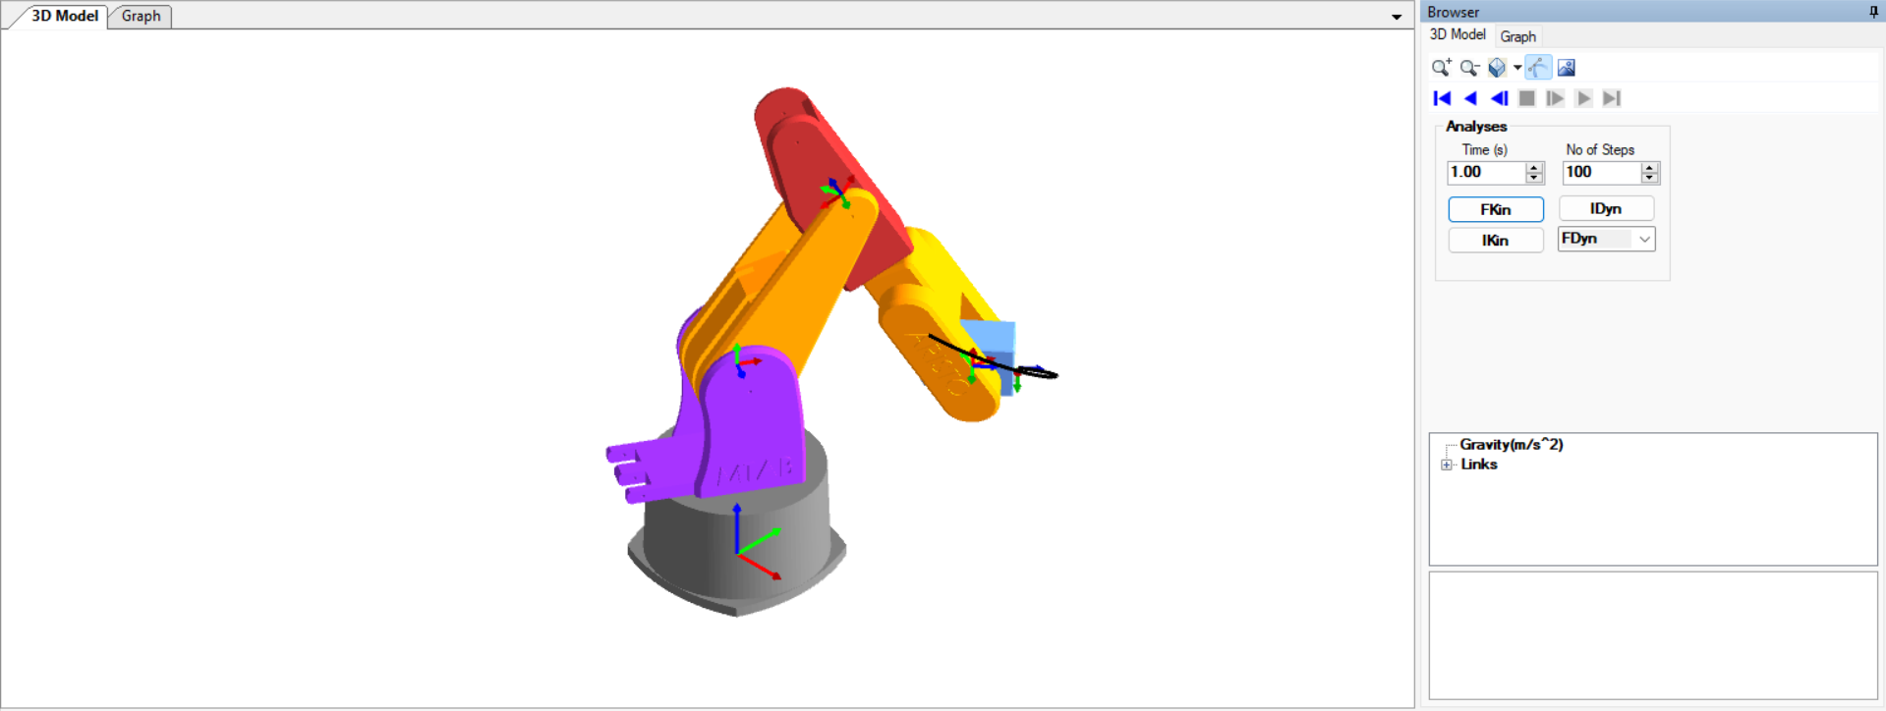

This is the after math of the scene after clicking the play button, the black like shows the path of the End Effector.

We can see the path in multile views by using the change view option in the 3D model tab

TOP VIEW –

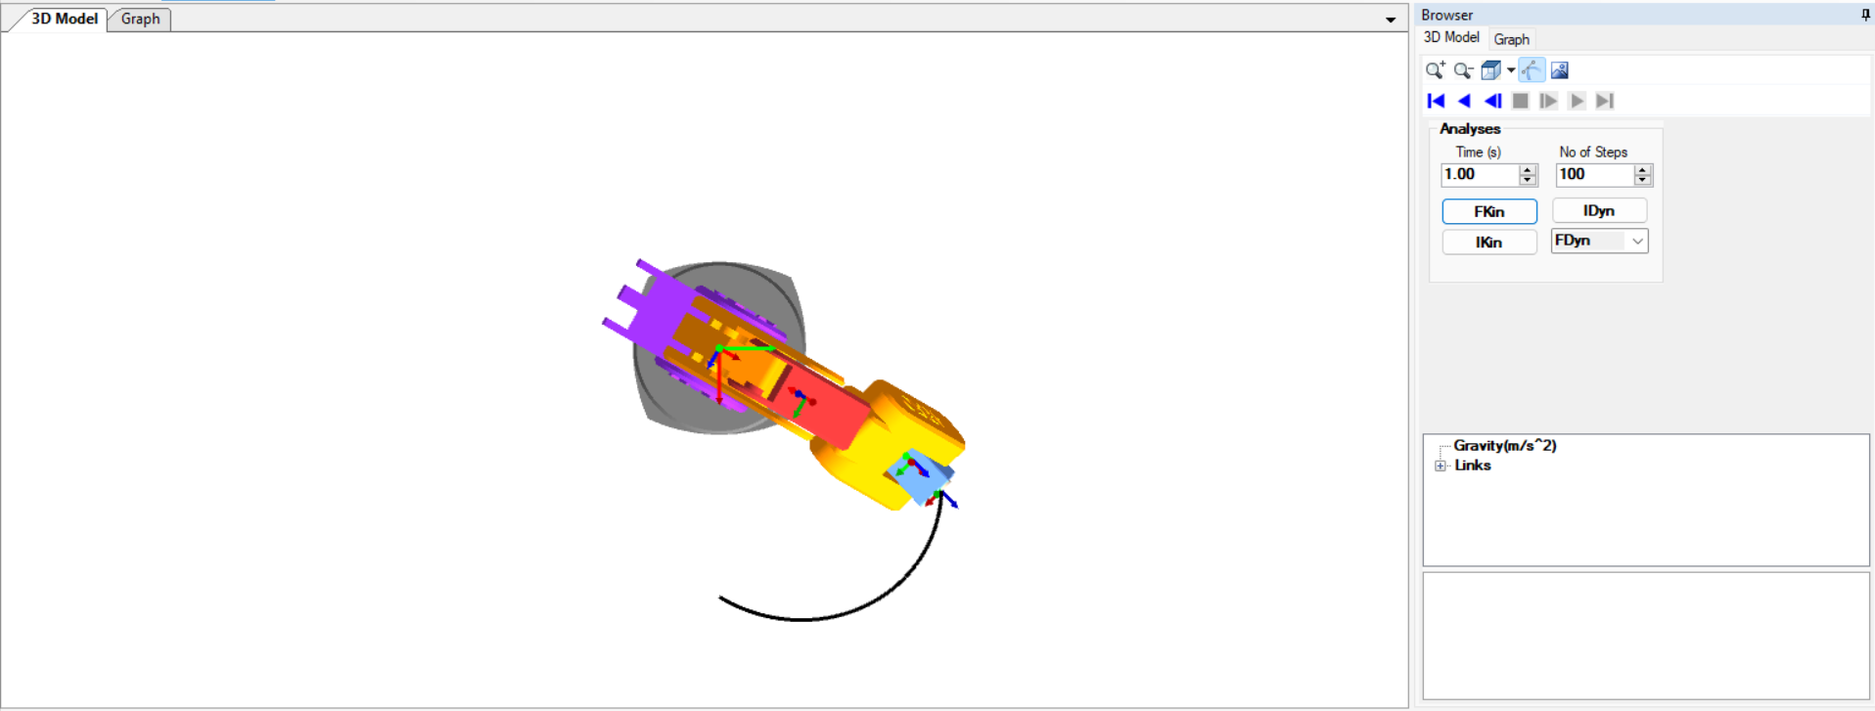

FRONT VIEW –

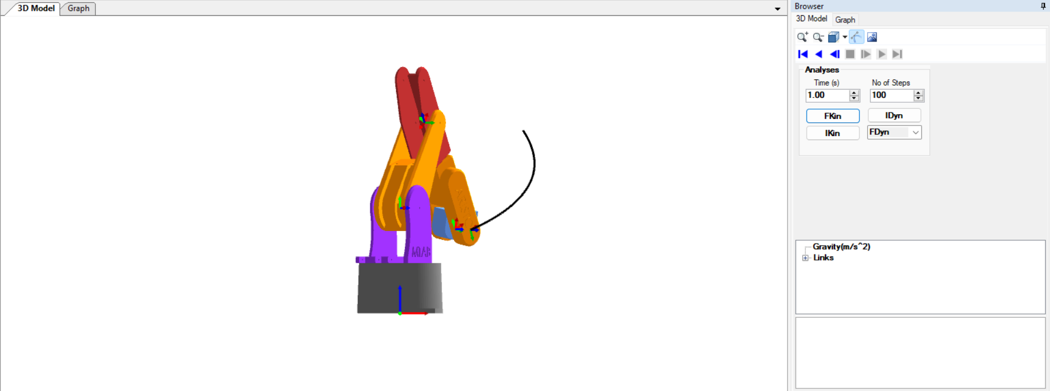

RIGHT VIEW –

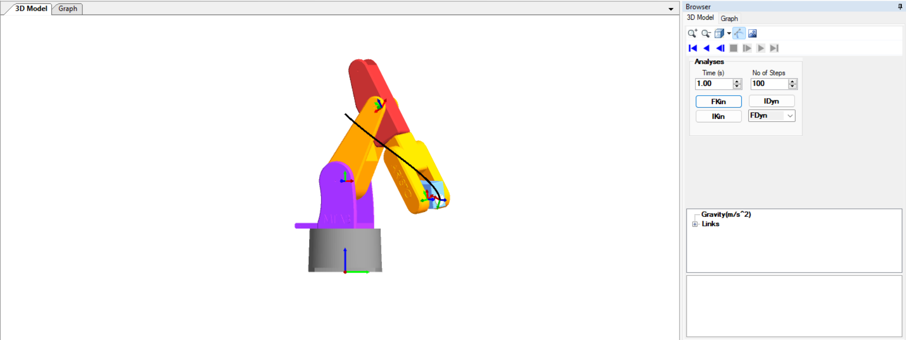

ISOMETIC VIEW –

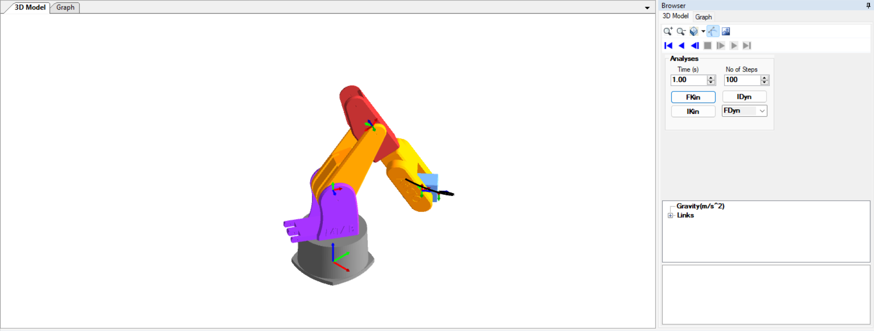

Now that we have seen the simulation of the ARISTO robot we can move on to its representation of motion in a graphical manner.

Going to the graph tab we can see an empty graph –

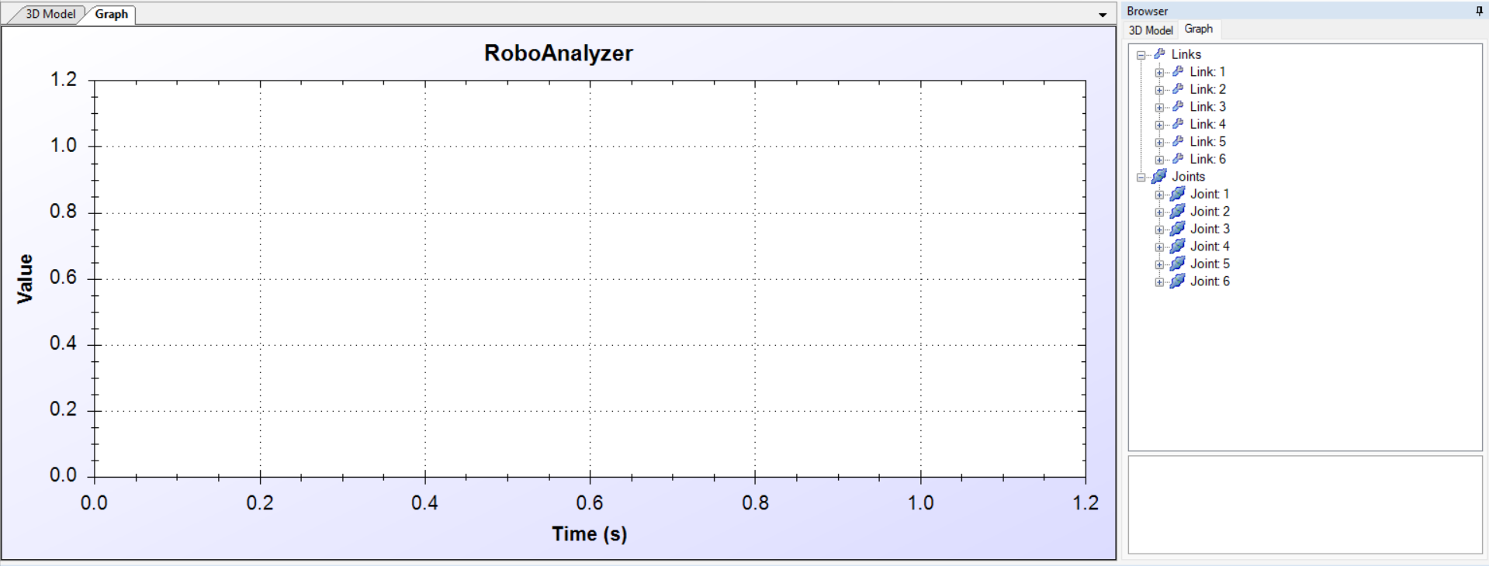

But as we expand the link 1 option and check the boxes for X,Y and Z axis movement.

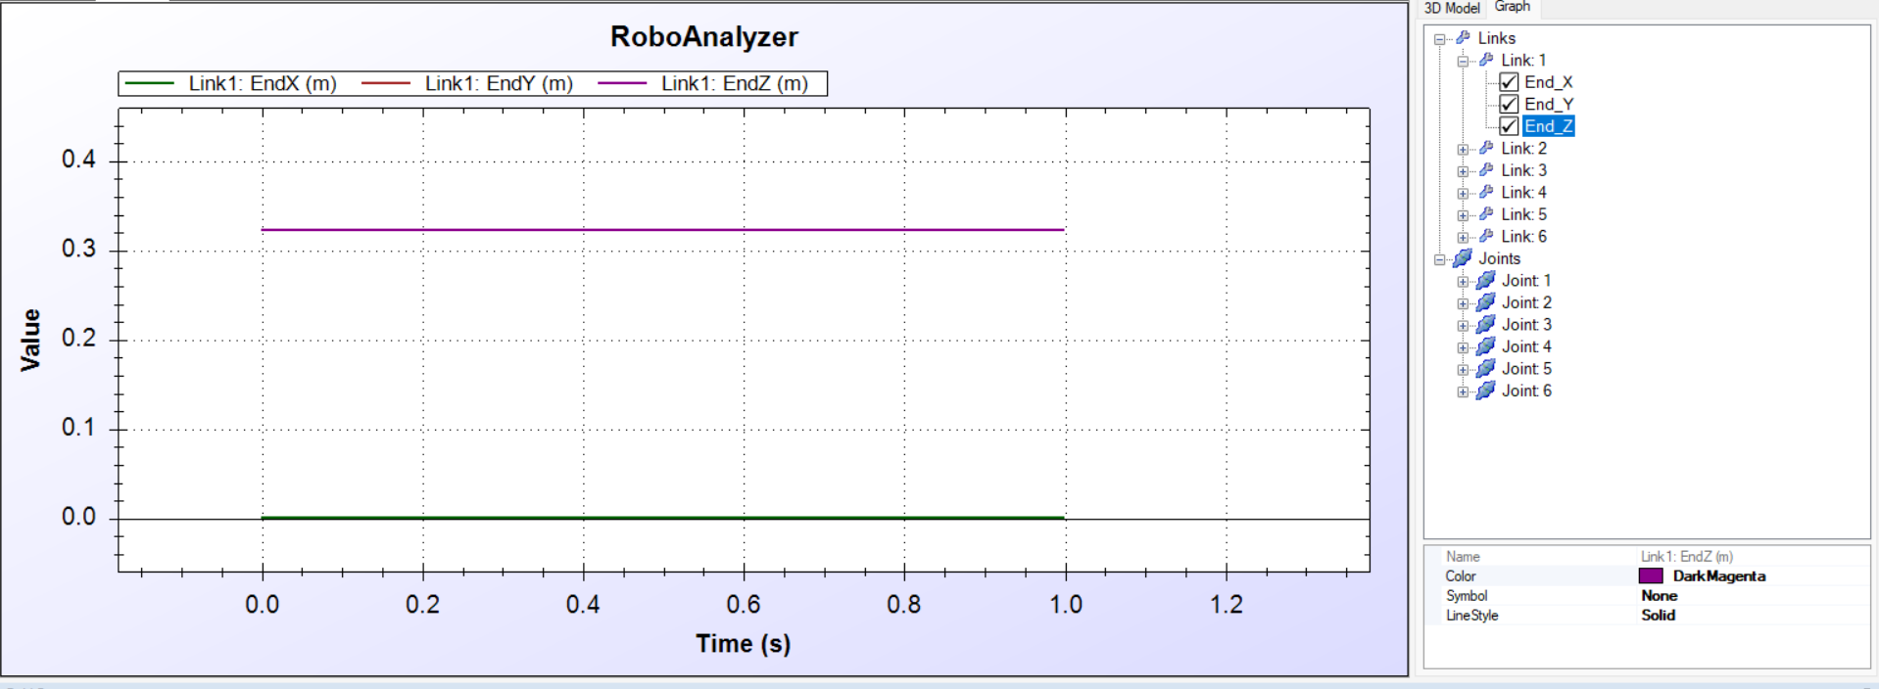

From the Legend we can see that link1’s X axis movement and Y axis movement is 0 whereas the Z axis movement is a constant 0.32 m in that second.

From the D-H parameter we get to know that link1’s position matrix before simulation is –

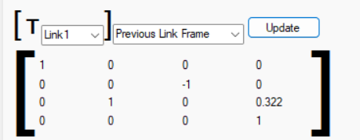

Post simulation position matrix of the link1 is –

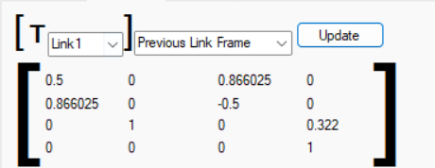

NOTE – We can use the Position matrix to find the position of the link by using inverse kinematics.

Now checking the graphical representation of link 2 (NOTE- first, disable the parameters of the link 1 to remove confuson and cluter on the screen) –

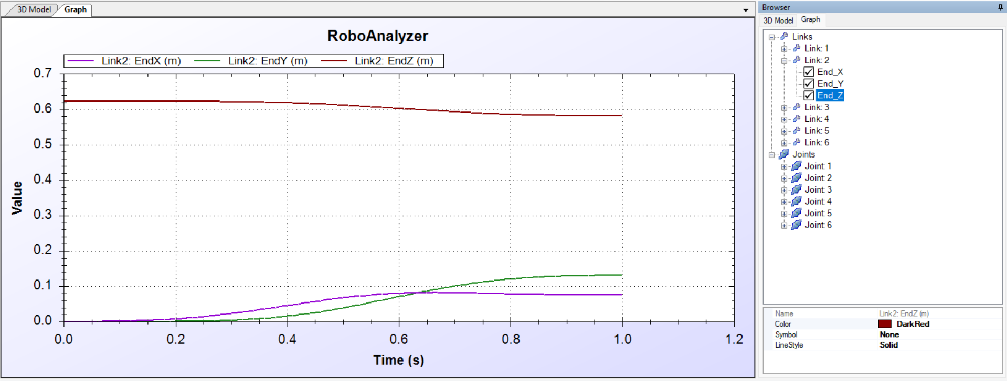

From this graph we can see that the link 2’s X axis speed is initially is 0 m/s and in one second it reduces to approxametly 0.9 m.

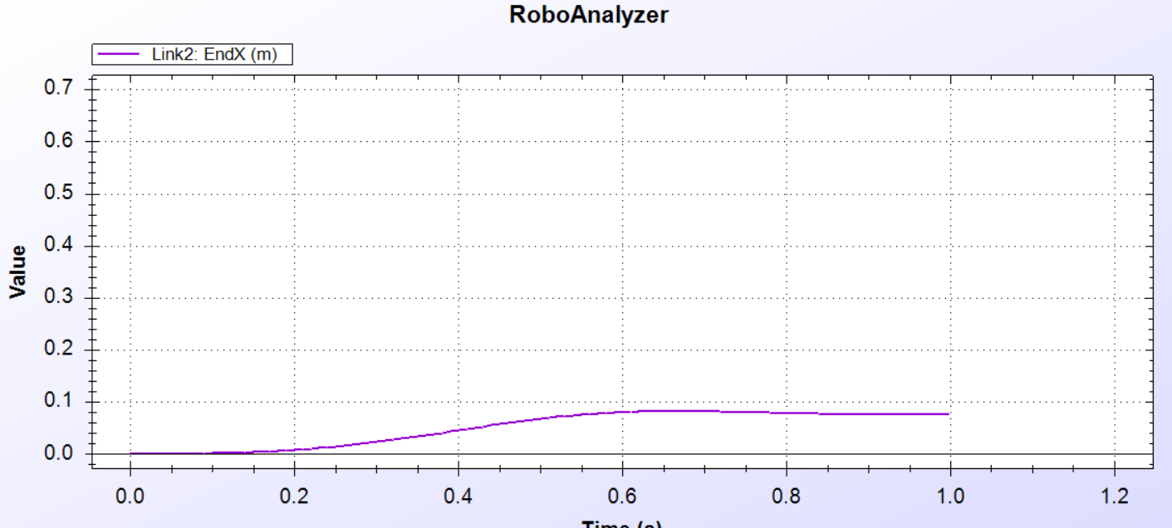

The speed of link 2 on the Y axis is zero m/s which increases to approxematly 0.12 m within one second.

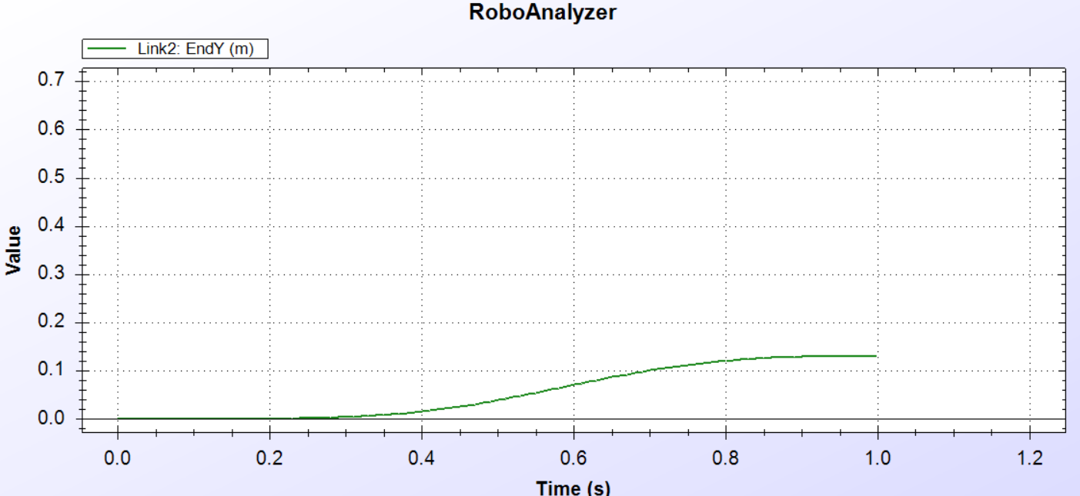

For the Z axis the movement starts at approximately 0.62 at zero seconds and then drecreeases in a curve to 0.58 m at one second.

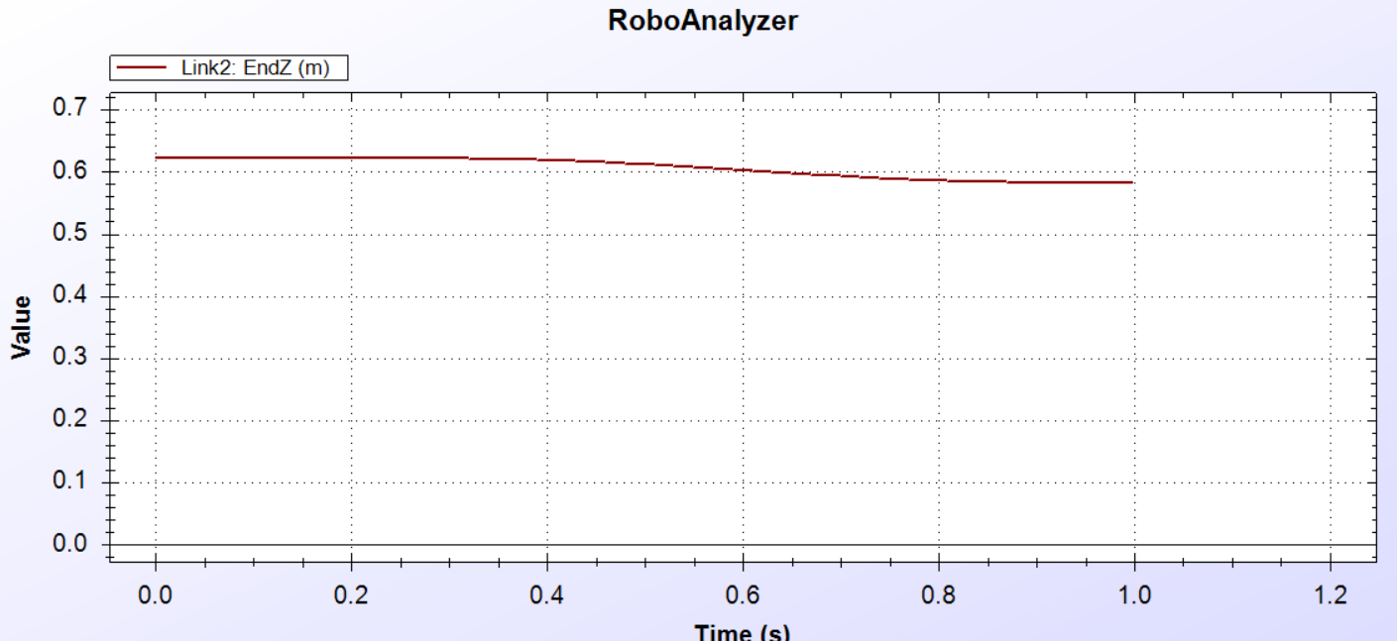

The position matrix of the Link 2 before simulation is given below-

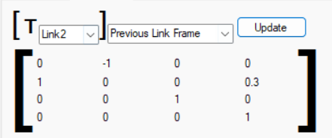

The position of link 2 post simulation is –

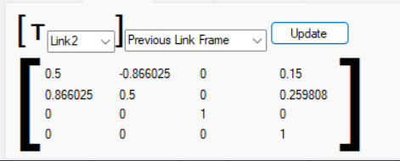

NOTE – We can use the Position matrix to find the position of the link by using inverse kinematics.

Now checking the graphical representation of link 3 (NOTE- first, disable the parameters of the link 2 to remove confuson and cluter on the screen) –

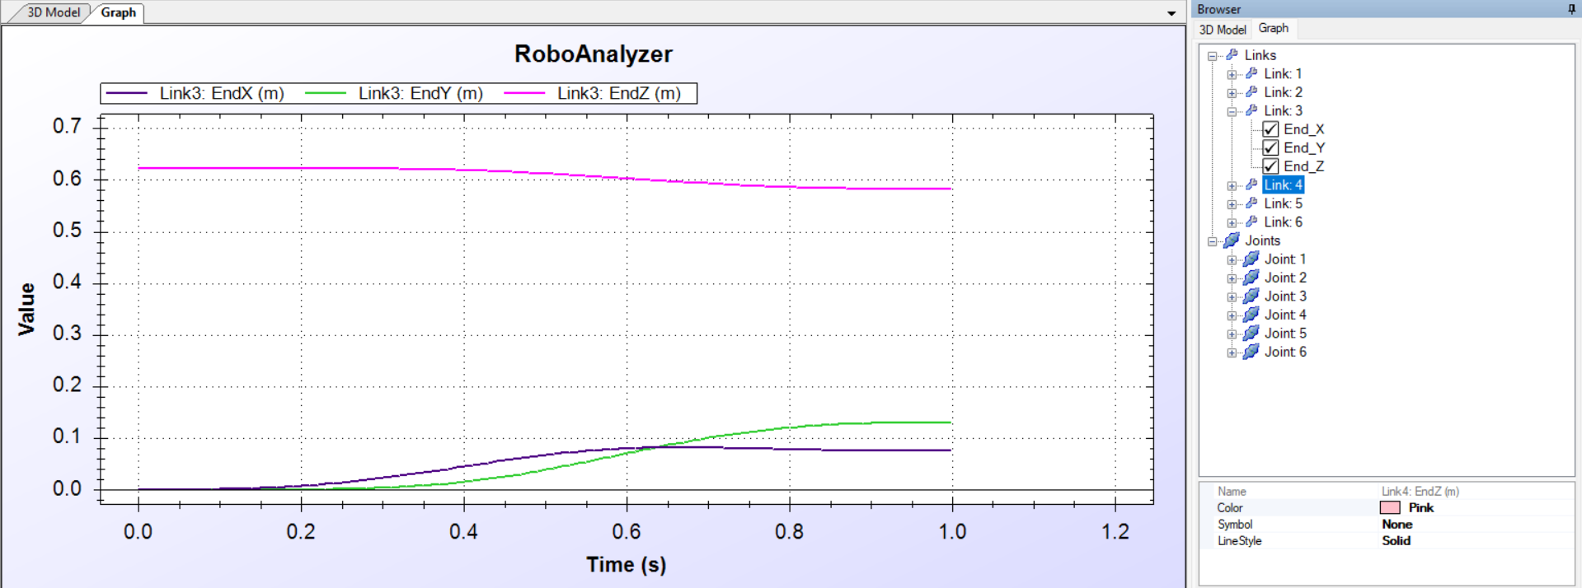

In this graph we can see that the X and Y axis movenemt speed in not much whereas the Z axis motion is high.

For the X axis movement the initial speed is zero m at zero seconds whereas thr peak speed for x axis movement is 0.8 m at approximately 0.60 seconds and then at one second the speed is approximately 0.5 m.

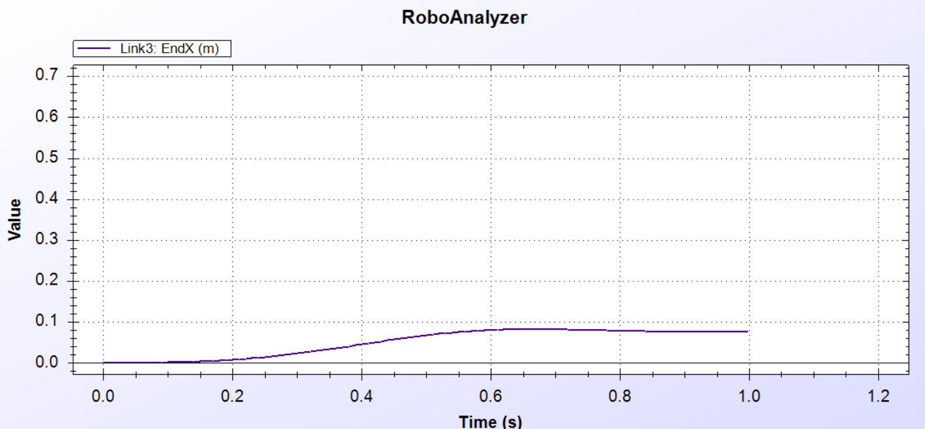

For the Y axis the initial value at zero seconds is zero where as it increases in a curve with the peak value of aproximatly 1.3 m at one second.

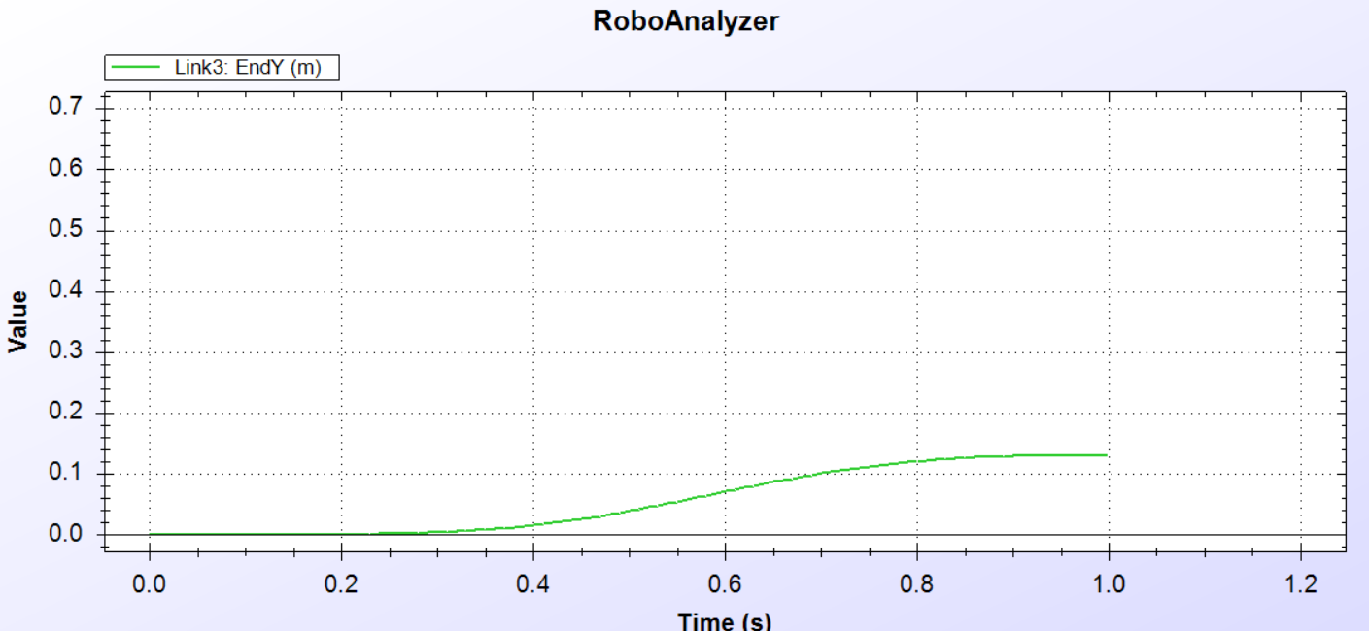

For the Z axis movement we can see that the movement starts at 0.62 m at zero seconds and reduces in a curve to around 0.58 m at one second.

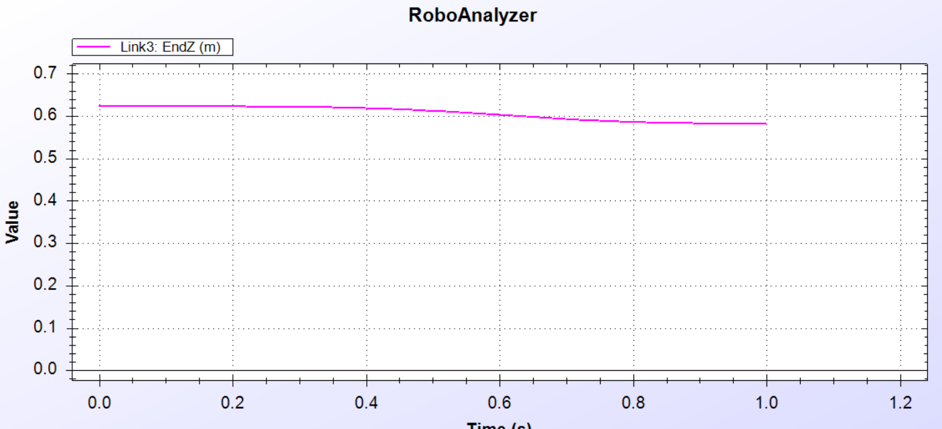

Now we can analyse the position matrix values of the link using the Link Config.

Prior to the start of simulation the position matrix values of the link is –

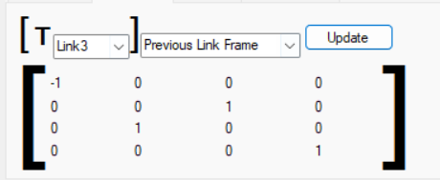

Post sumilation of the Robot gives us the value of the position matrix as –

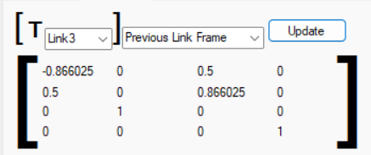

NOTE – We can use the Position matrix to find the position of the link by using inverse kinematics.

Now checking the graphical representation of link 4 (NOTE- first, disable the parameters of the link 3 to remove confuson and cluter on the screen) –

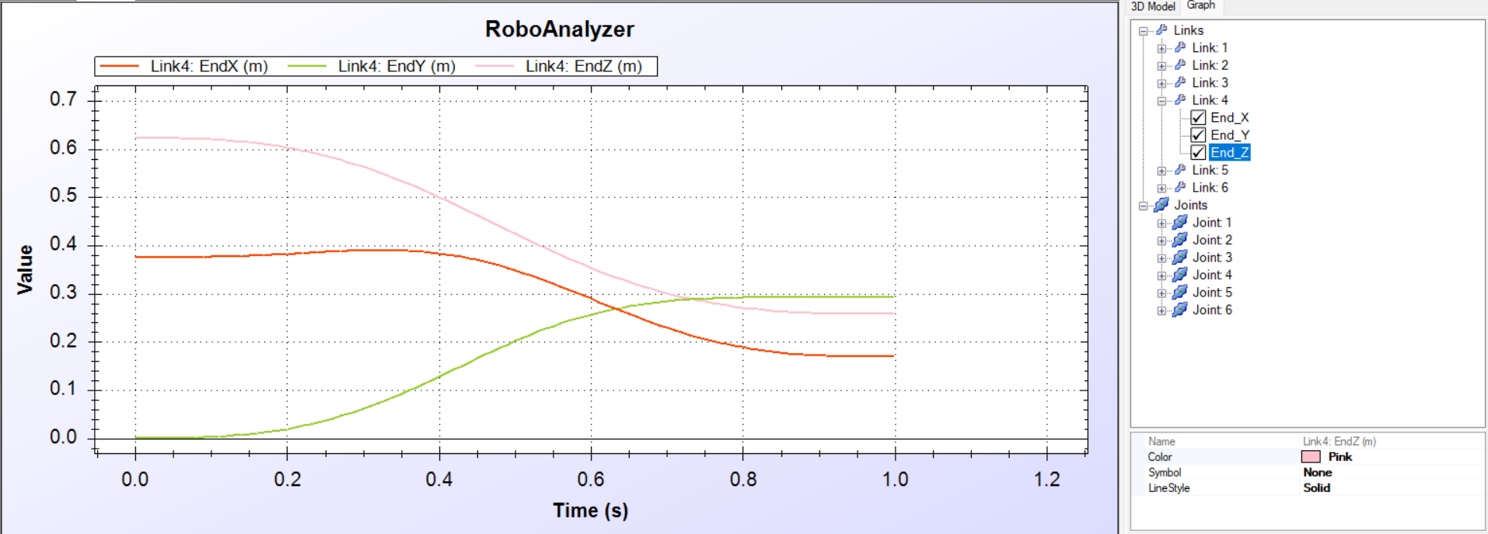

For Link three there is signficant changes in the graph, in the graph we can see that the X axis movement is 0.38 m at zero seconds and it reaches with a peak of 0.4 m at 0.30 seconds, from that point the value decreases to approximately 0.18 at once second.

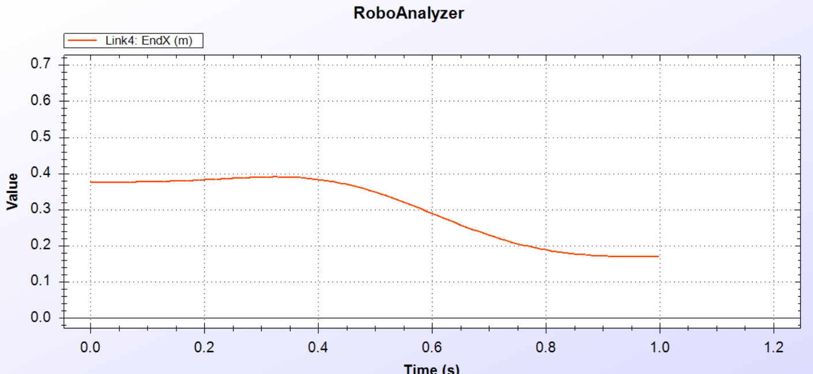

For the Y axis movement the initial value is zero m at o seconcs with a curved slope reaching 0.3 m at 0.8 seconds and stays constant till the simulation ends.

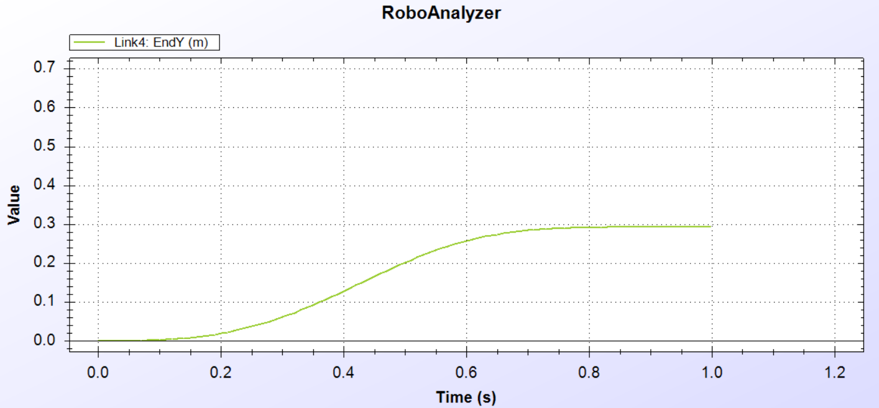

For the Z axis movement of the Link since the movement of the link is from a peak of 0.62 m at zero seconds and reduces with a curve to its minimum of 0.34 m at one seconds right before the simulation ends.

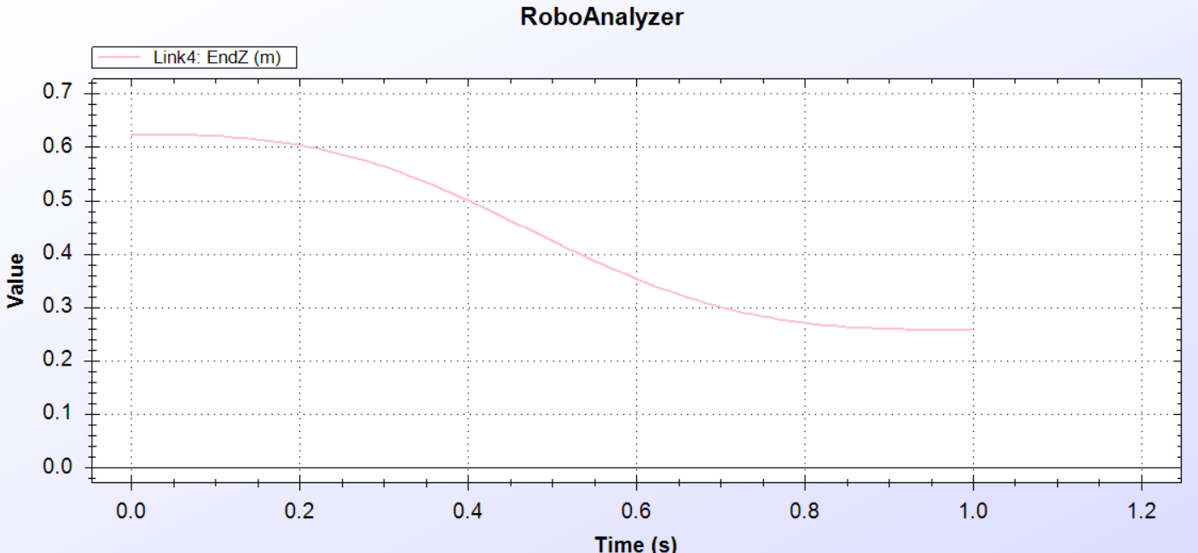

The Link config prior to the start of the simulation is-

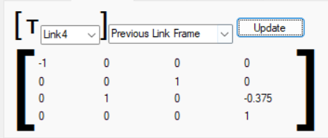

Where as the position matrix of the link post simulation is-

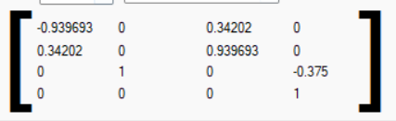

NOTE – We can use the Position matrix to find the position of the link by using inverse kinematics.

Now checking the graphical representation of link 5 (NOTE- first, disable the parameters of the link 4 to remove confuson and cluter on the screen) –

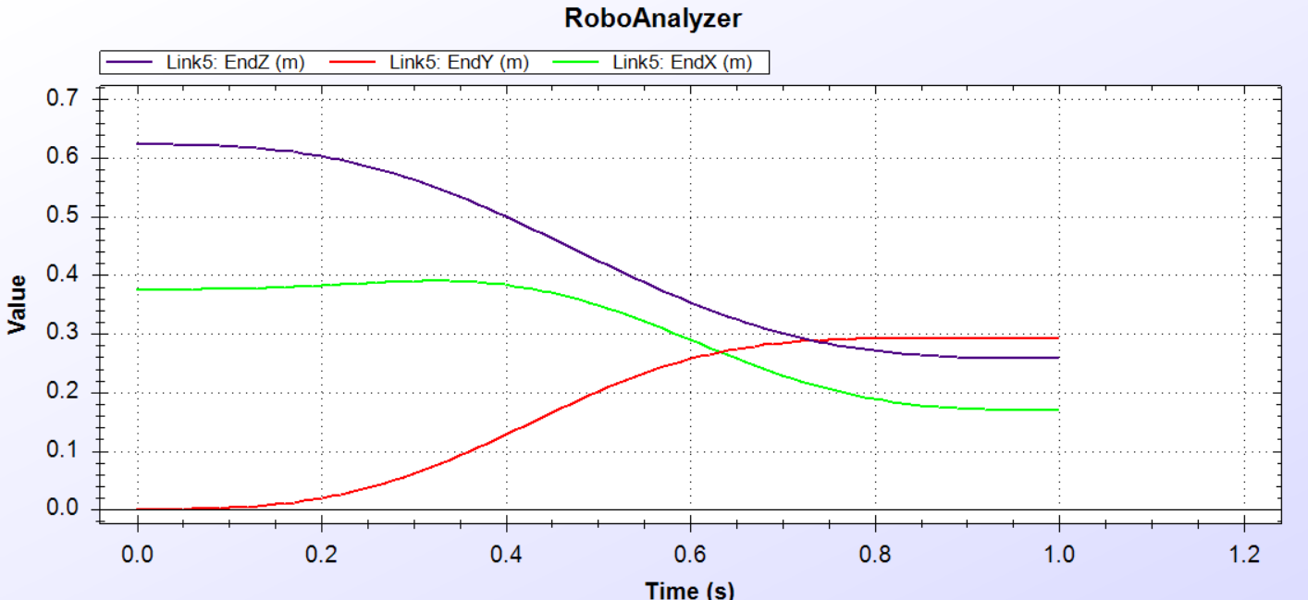

For Link 5 we can see that there is significant difference in the initial values of the three axis but the three end up at speeds very close to each other.

For X axis we can see that the initial speed of the link is around 0.38 m at zero seconds where it slightly increases its speed to around 0.39 m 0.35 seconds which then redices through a curve to be around 0.16 m at one second.

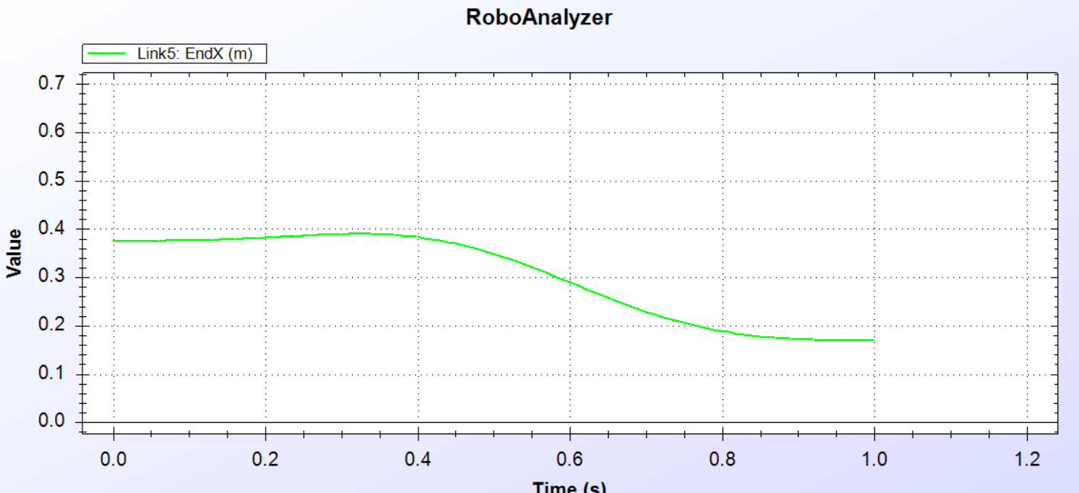

For the visualization of the movement of the Link in the Y axis, we can see that the initial speed of the link in the Y axis is zero at zero seconds where it it increases in a curved manner to it’s peak value of around 0.3 m at one second.

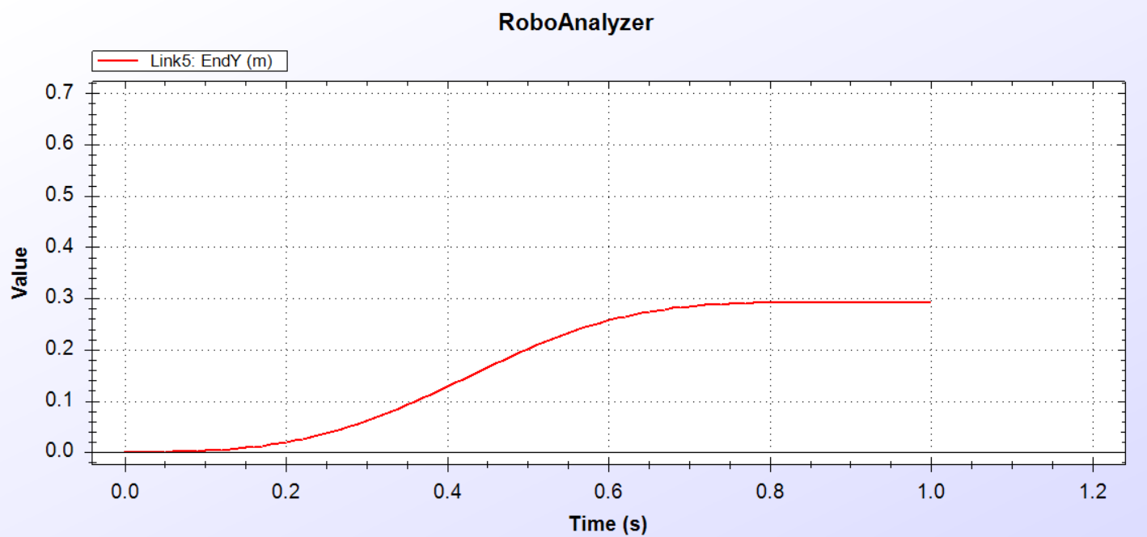

For the link’s movement in the Z axis we can see that the link’s initial speed is around 0.62 m at zero seconds, as the simulation comes to an end the final speed of the link decreases in a curved mannet to 0.26 m at one second.

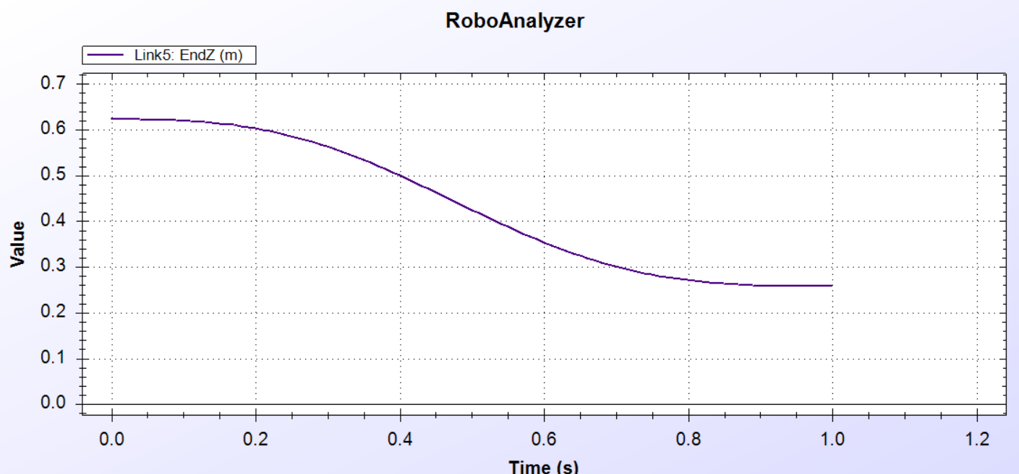

We can also find the Position matrix of the robot using the Link config tab –

The Position maatrix of the link prior the simulation –

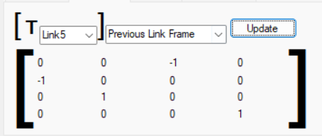

The position matrix post simulation is –

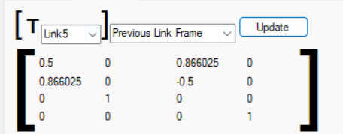

NOTE – We can use the Position matrix to find the position of the link by using inverse kinematics.

Now checking the graphical representation of link 6 (NOTE- first, disable the parameters of the link 5 to remove confuson and cluter on the screen) –

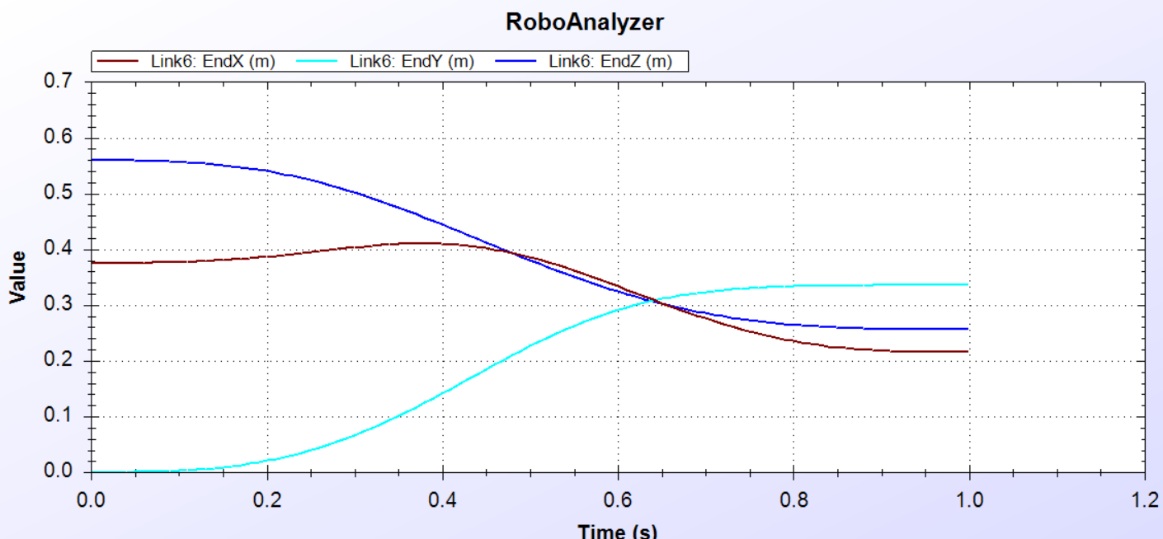

From the graph we can see the X, Y, Z motion of the ARISTO Robot from Link 6

From this we can see that the X axis movement of the link is from around 0.38 m at zero seconds with a peak of around 0.42 m at around o.35 seconds which gradually decreases to the value of around 0.22 m at one second.

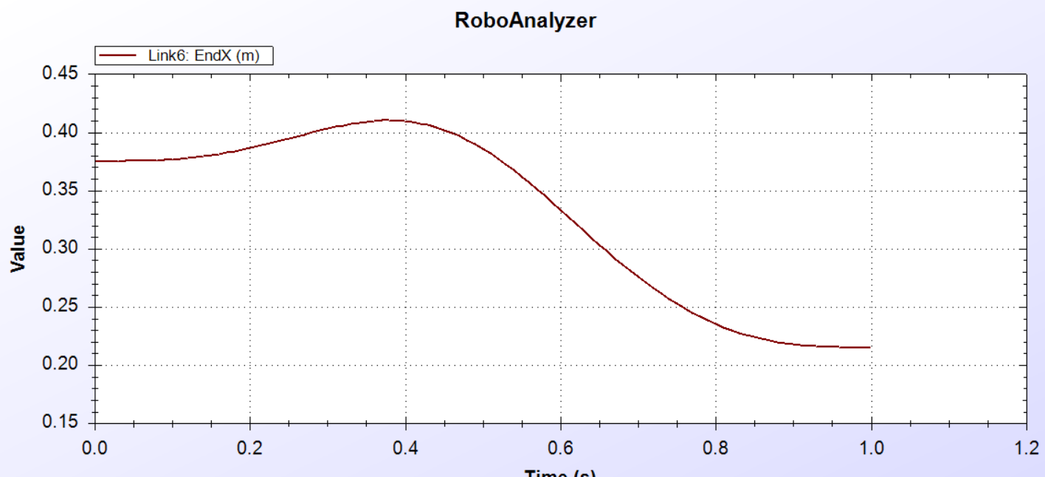

Now we can see that the Y axis movement of the link is from zero m at zero seconds gradually increases to the value of around 0.34 m at one second.

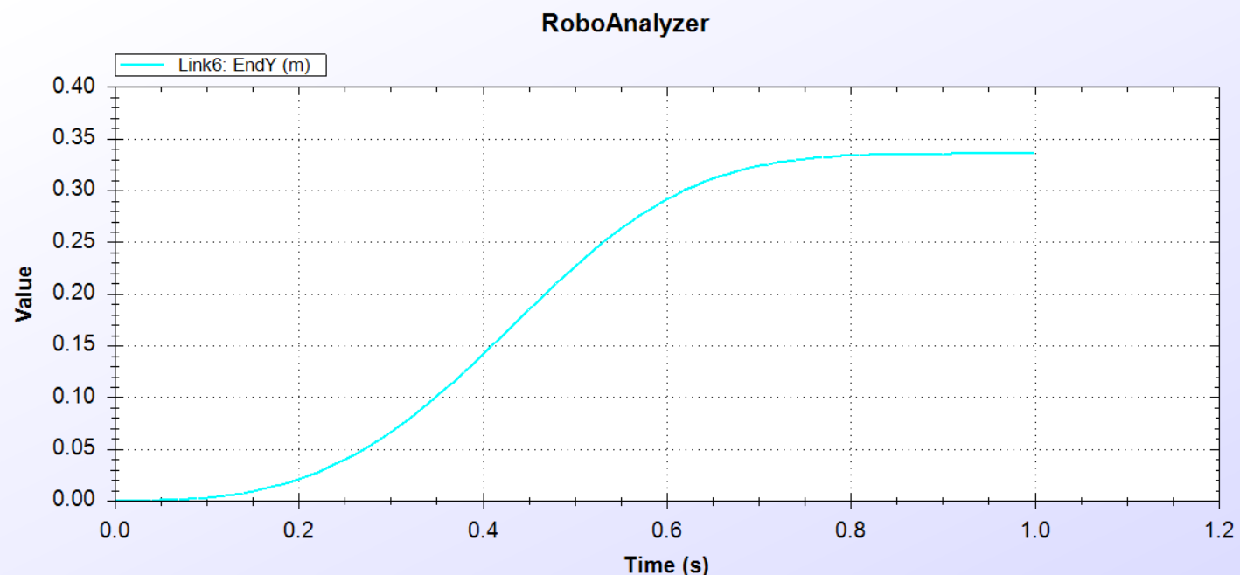

Now we can see that the Z axis movement of the link is from around 0.56 m at zero seconds gradually decreases to the value of around 0.26 m at one second.

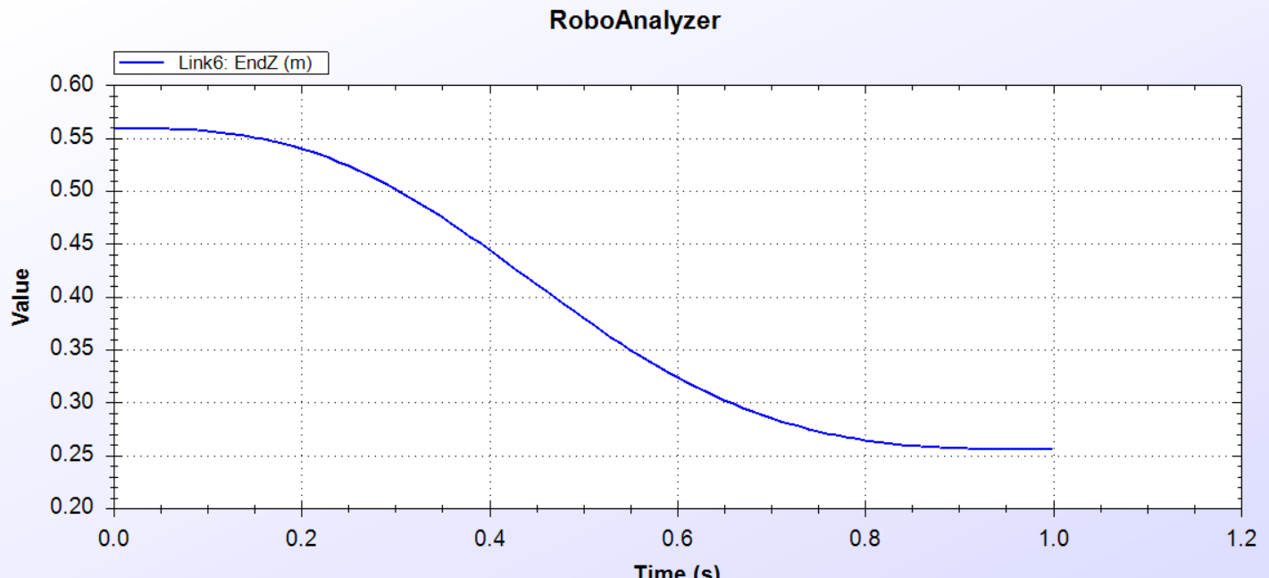

Now checking the position matrix of the link using the link config tab-

The position matrix prior the simulation is –

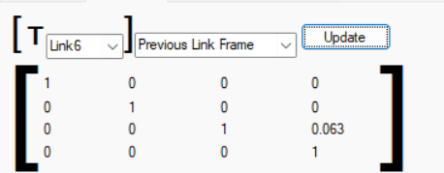

The position matrix after the simulation is –

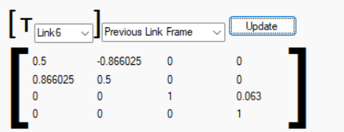

NOTE – We can use the Position matrix to find the position of the link by using inverse kinematics.

Now that we have seen the movement of the links, we can also see the movement of the Joints in Forward kinematics.

We will not only use the graphical representaion to check the joint movement but also the EE config tab to check the poition matrix of the ARISTO Robot prior and post simulation.

For the Joint one the following graphical representation is shown-

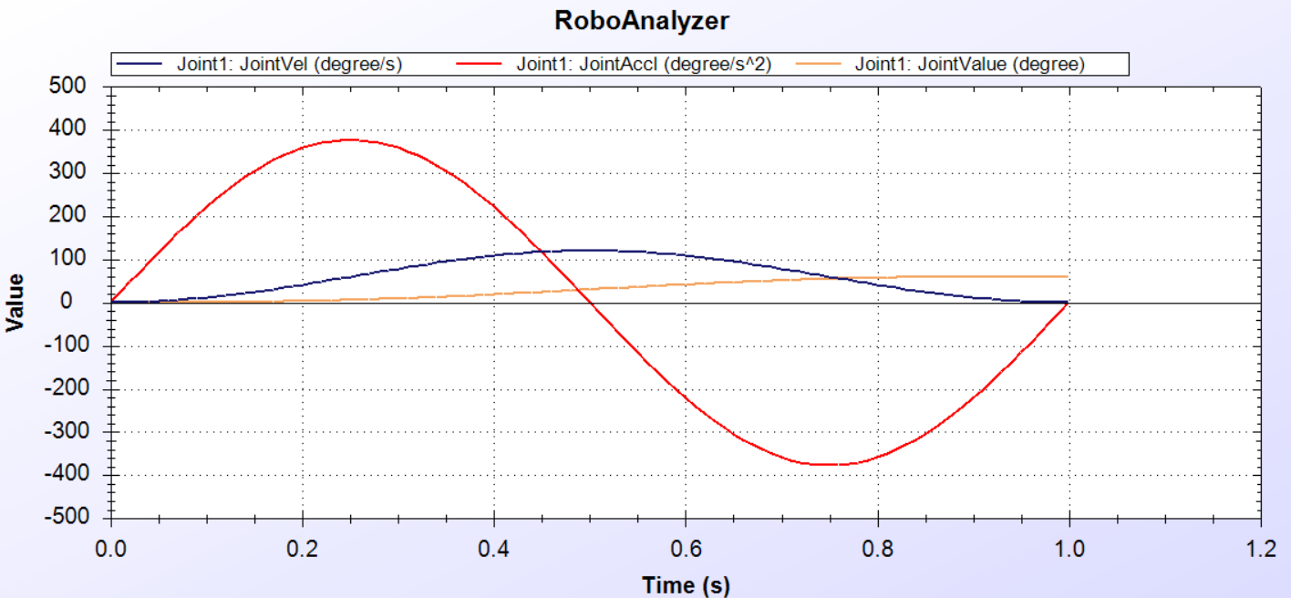

We can see that the lines represent the joint motion of the 1st joint of the ARISTO robot,

The 1st Joint of the robot has a joint offset of 0.322 m, a variable joint angle, Link length of 0 m,

Twist angle of 90°, initial value of 0° and a final value of 60°.



The Graphical representation shows the –

Joint Value – We can see that the value of the joint motion is zero at zero seconds whereas it gradually increases to around 60 ° at one second.

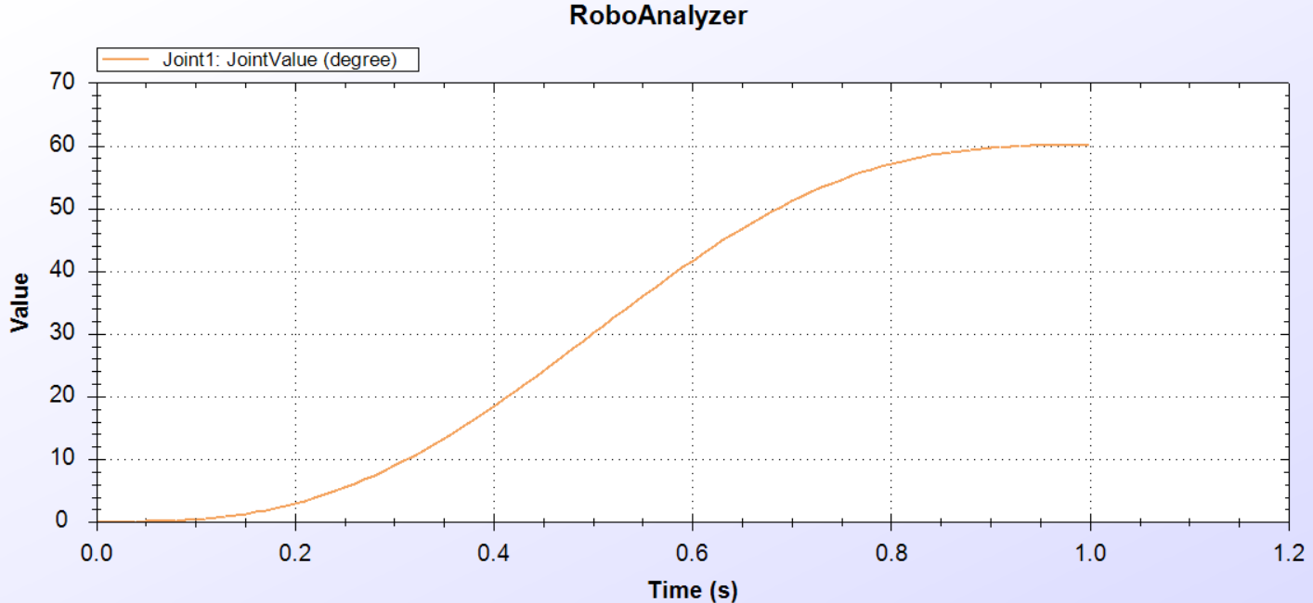

Joint Velocity – We can see that the value of the joint velocity is zero at zero seconds whereas it gradually increases to around 60 ° at around 0.5 seconds and then reduces to 0 ° at one second.

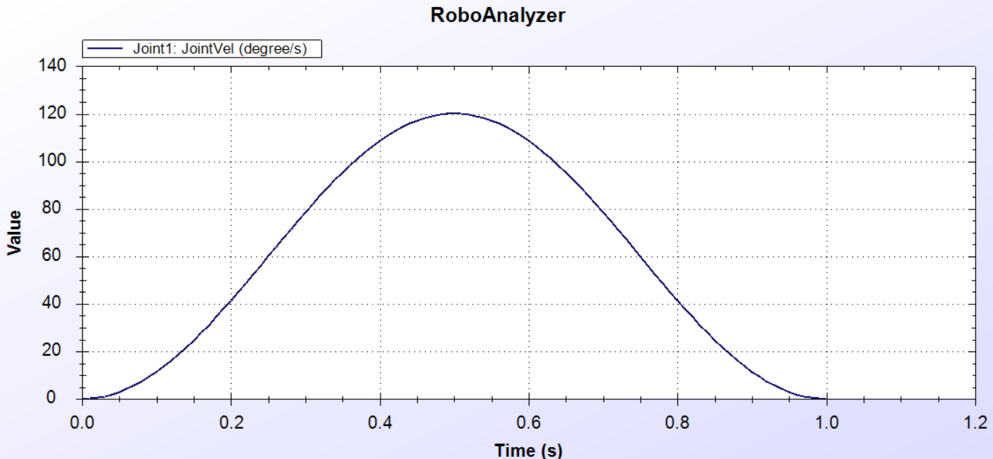

Joint Acceleration – We can see that the value of the joint acceleration is zero at zero seconds whereas it gradually increases to around 380 °/ second^2 at around 0.25 seconds and then reduces to 0 ° at 0.5 second, then the value further reduces to the value of -380 °/ second^2 at around 0.75 seconds which then resets to the value of 0 °/second^2 at one second.

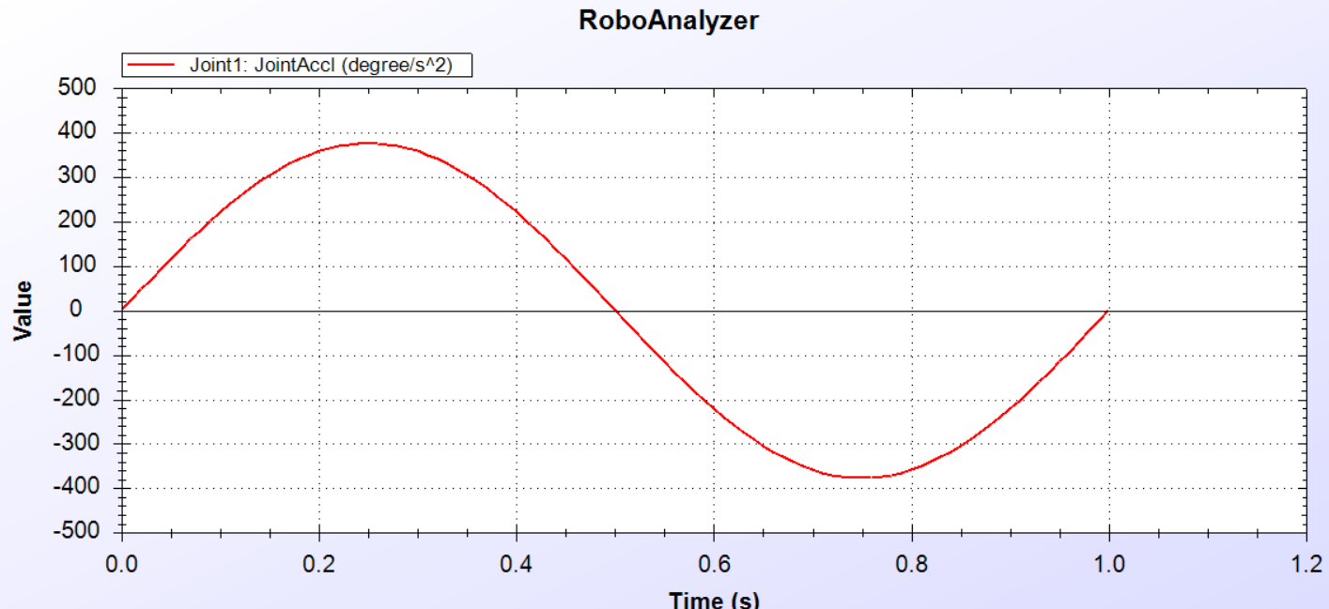

NOTE – No Force/Torq value since we are analyzing a forward kinematics.

For the Joint two the following graphical representation is shown-

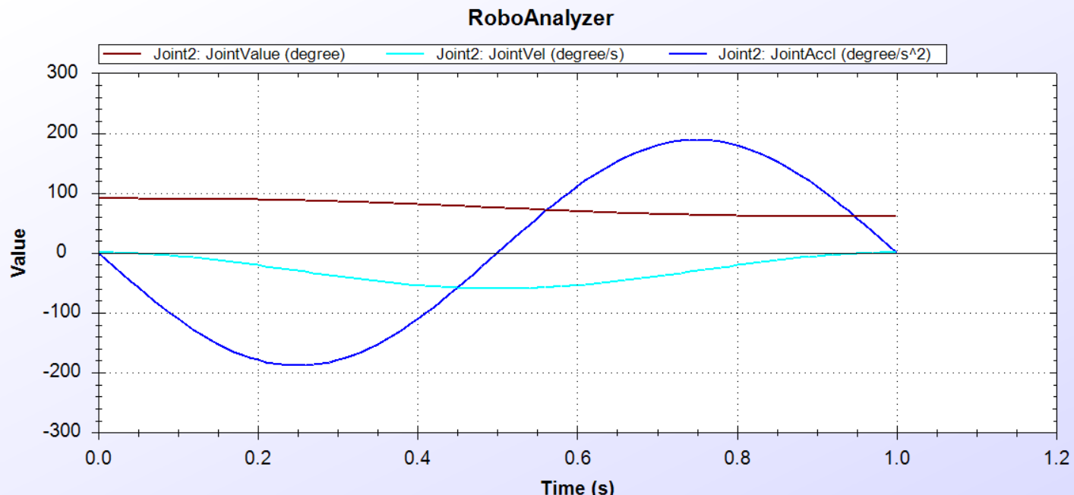

The 2nd Joint of the robot has a joint offset of 0 m, a variable joint angle, Link length of 0.3 m,

Twist angle of 0°, initial value of 90° and a final value of 60°.



The Graphical representation shows the –

Joint Value – We can see that the value of the joint motion is 90 ° at zero seconds whereas it gradually increases to around 60 ° at one second.

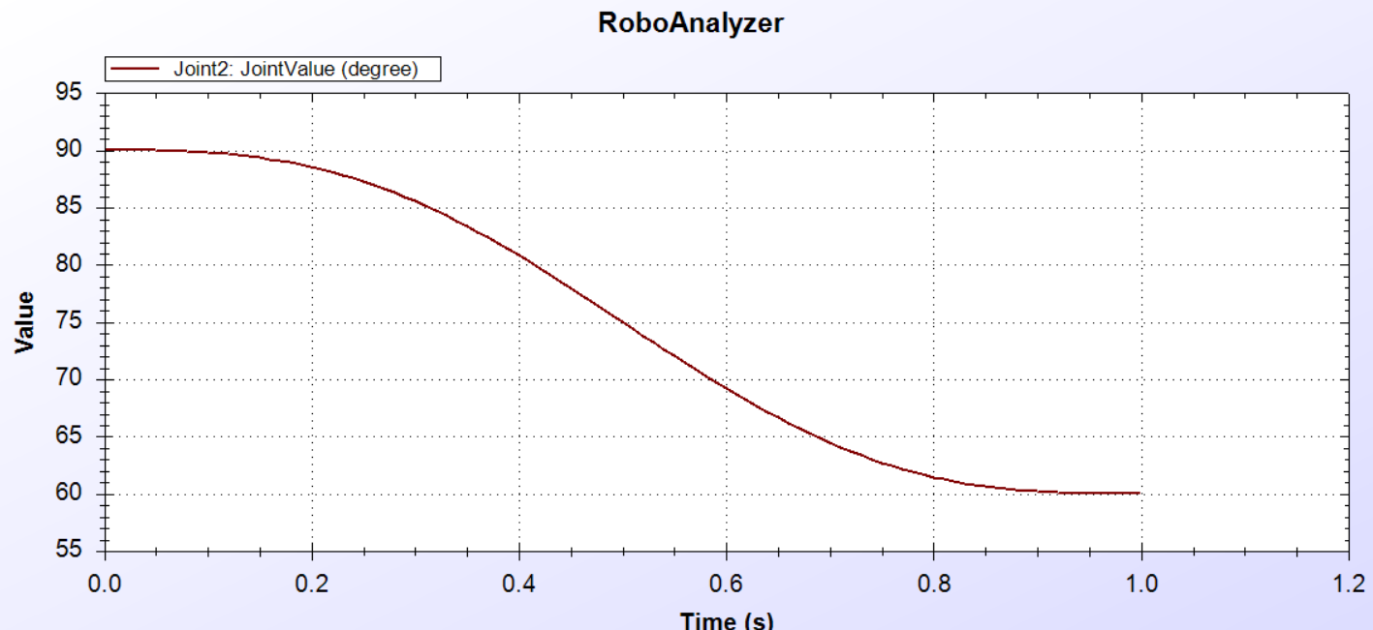

Joint Velocity – We can see that the value of the joint velocity is zero at zero seconds whereas it gradually decreases to around -60 °/second at around 0.5 seconds and then resets to 0 °/second at one second.

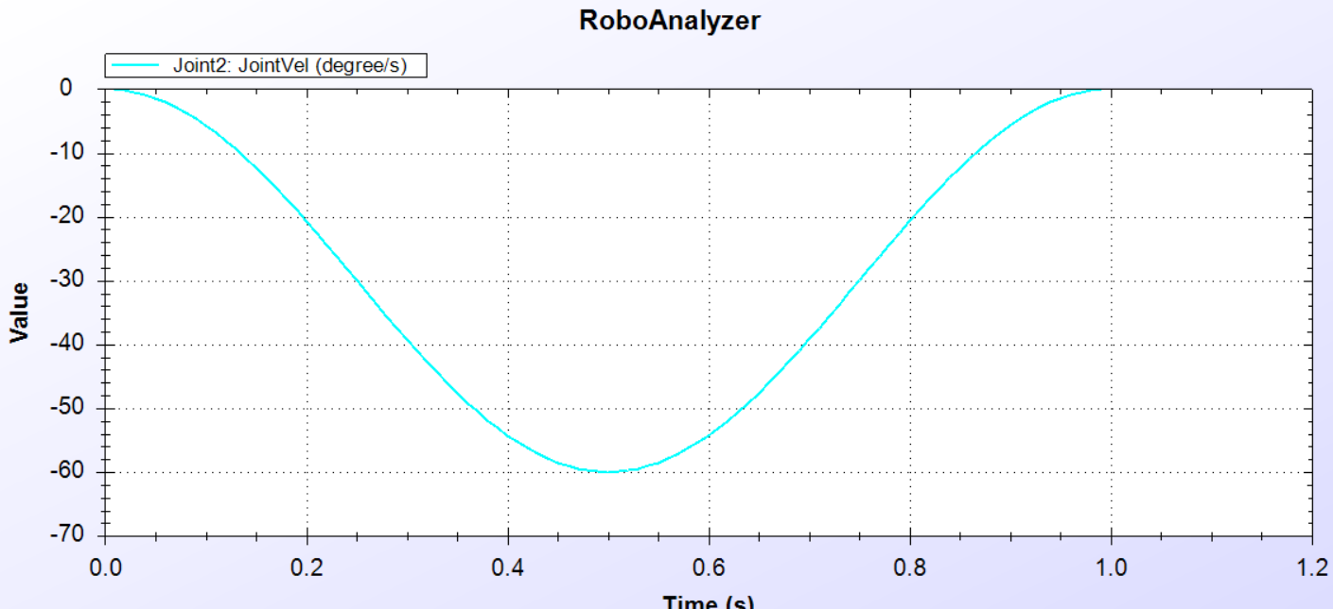

Joint Acceleration – We can see that the value of the joint acceleration is zero at zero seconds whereas it gradually decreases to around -180 °/ second^2 at around 0.25 seconds and then resets to 0 ° at 0.5 seconds, then the value further increases to the value of around 180 °/ second^2 at around 0.75 seconds which then resets to the value of 0 °/second^2 at one second.

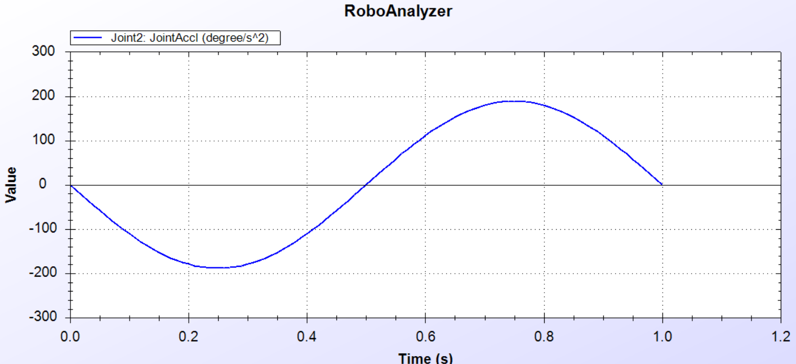

NOTE – No Force/Torq value since we are analyzing a forward kinematics.

For the Joint three the following graphical representation is shown-

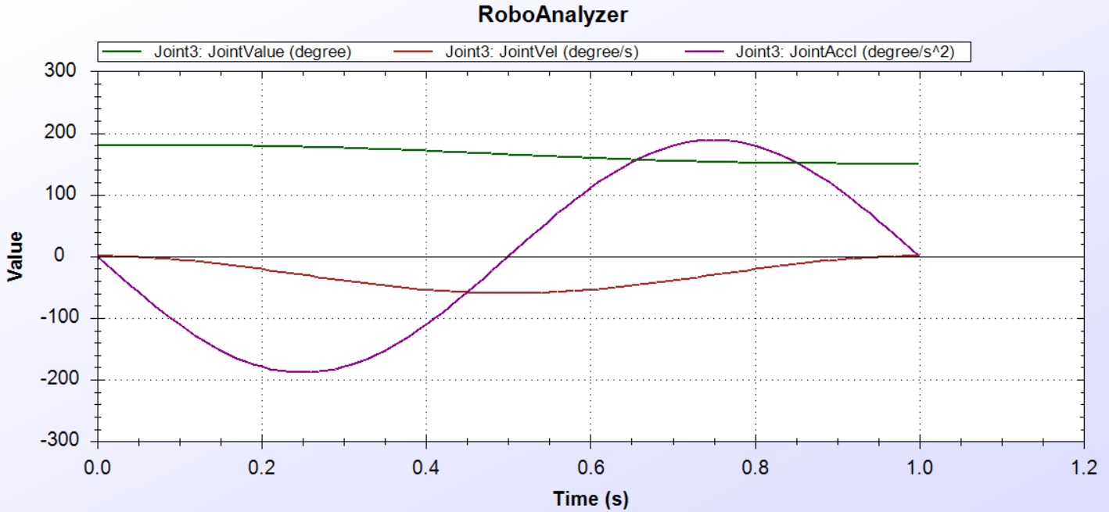

The 3rd Joint of the robot has a joint offset of 0 m, a variable joint angle, Link length of 0 m,

Twist angle of 90°, initial value of 180° and a final value of 150°.



The Graphical representation shows the –

Joint Value – We can see that the value of the joint motion is 180 ° at zero seconds whereas it gradually decreases to around 150 ° at one second.

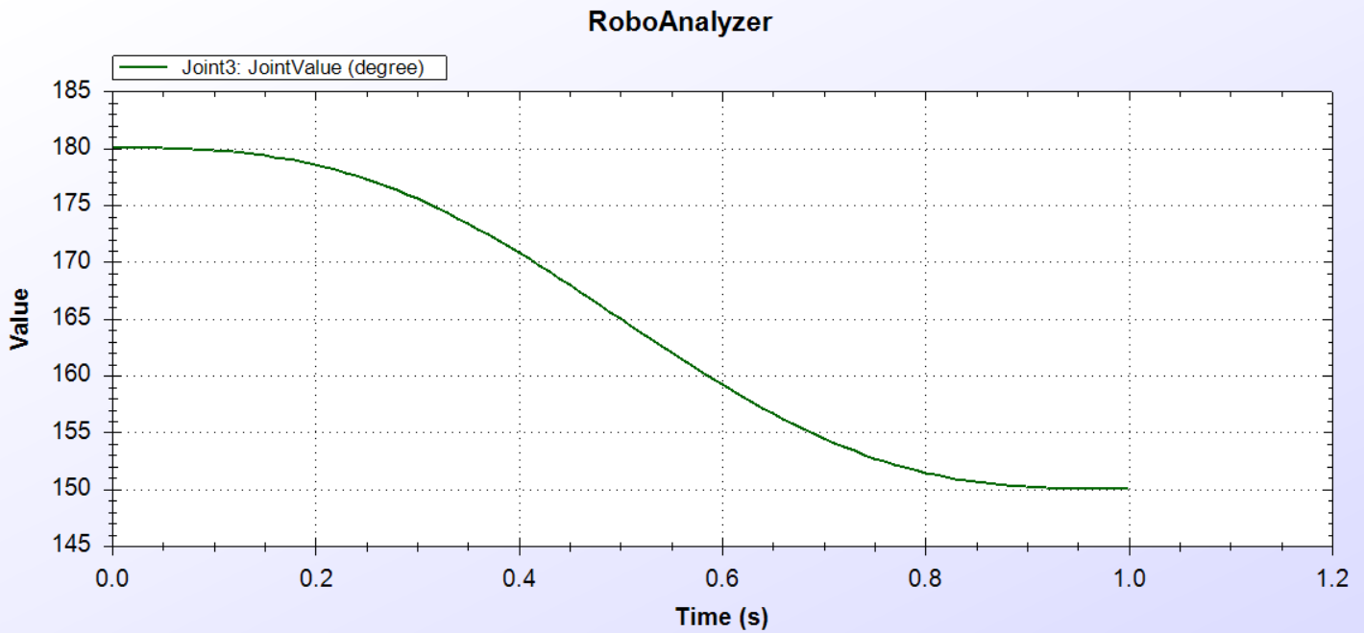

Joint Velocity – We can see that the value of the joint velocity is zero at zero seconds whereas it gradually decreases to around -60 °/second at around 0.5 seconds and then resets to 0 °/second at one second.

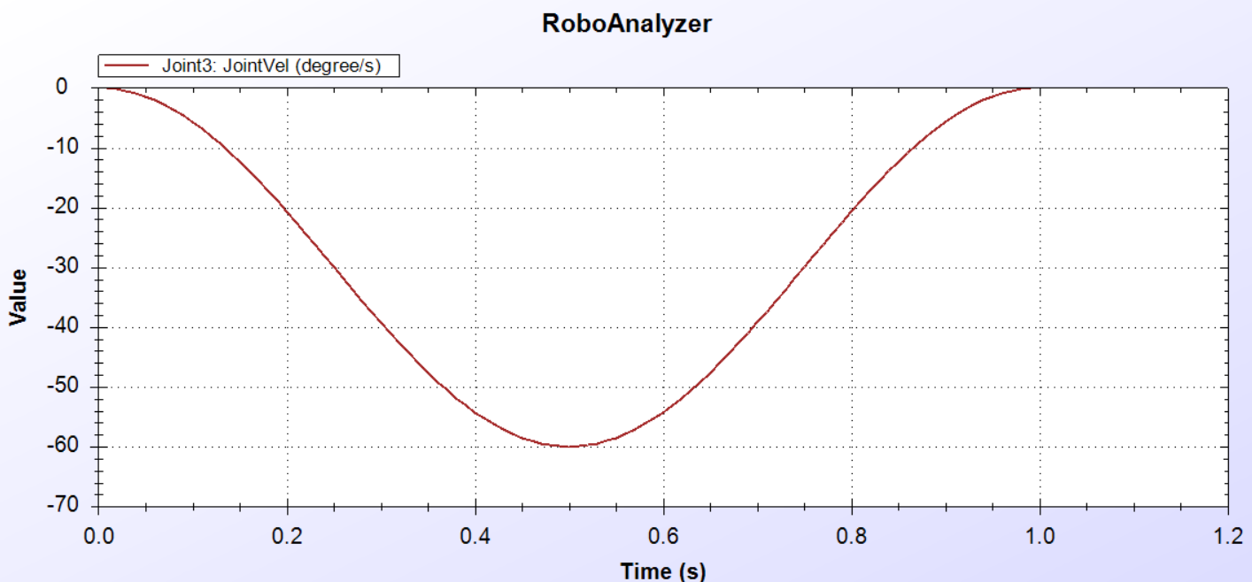

Joint Acceleration – We can see that the value of the joint acceleration is zero at zero seconds whereas it gradually decreases to around -180 °/ second^2 at around 0.25 seconds and then resets to 0 ° at 0.5 seconds, then the value further increases to the value of around 180 °/ second^2 at around 0.75 seconds which then resets to the value of 0 °/second^2 at one second.

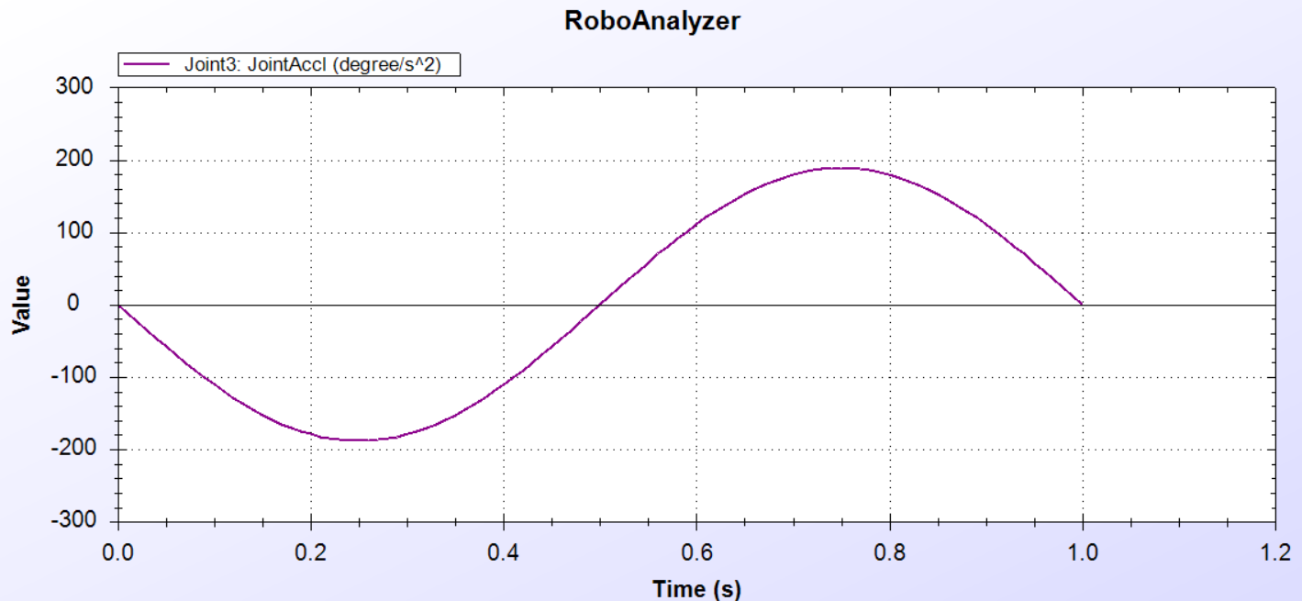

NOTE – No Force/Torq value since we are analyzing a forward kinematics.

For the Joint four the following graphical representation is shown-

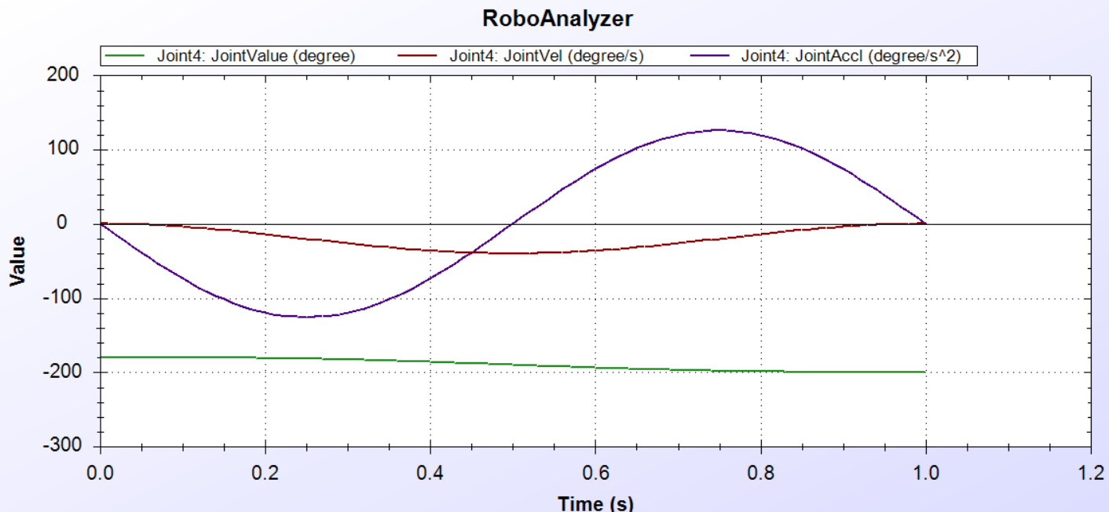

The 4th Joint of the robot has a joint offset of -0.375 m, a variable joint angle, Link length of 0 m,

Twist angle of 90°, initial value of -180° and a final value of -200°.



The Graphical representation shows the –

Joint Value – We can see that the value of the joint motion is -180 ° at zero seconds whereas it gradually decreases to around 200 ° at one second.

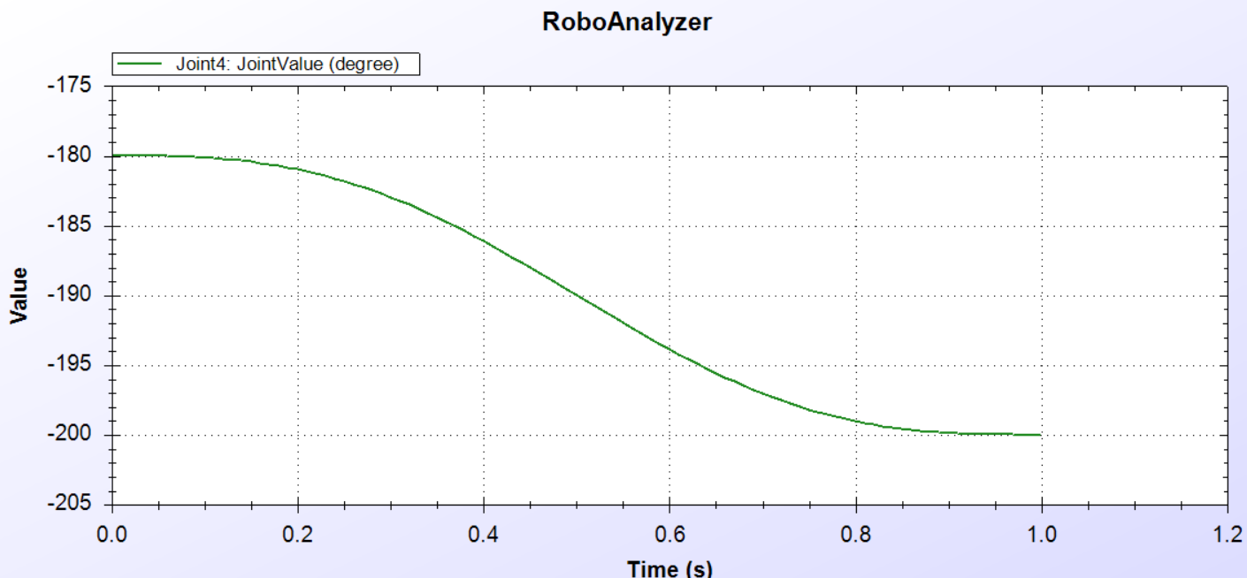

Joint Velocity – We can see that the value of the joint velocity is zero at zero seconds whereas it gradually decreases to around -40 °/second at around 0.5 seconds and then resets to 0 °/second at one second.

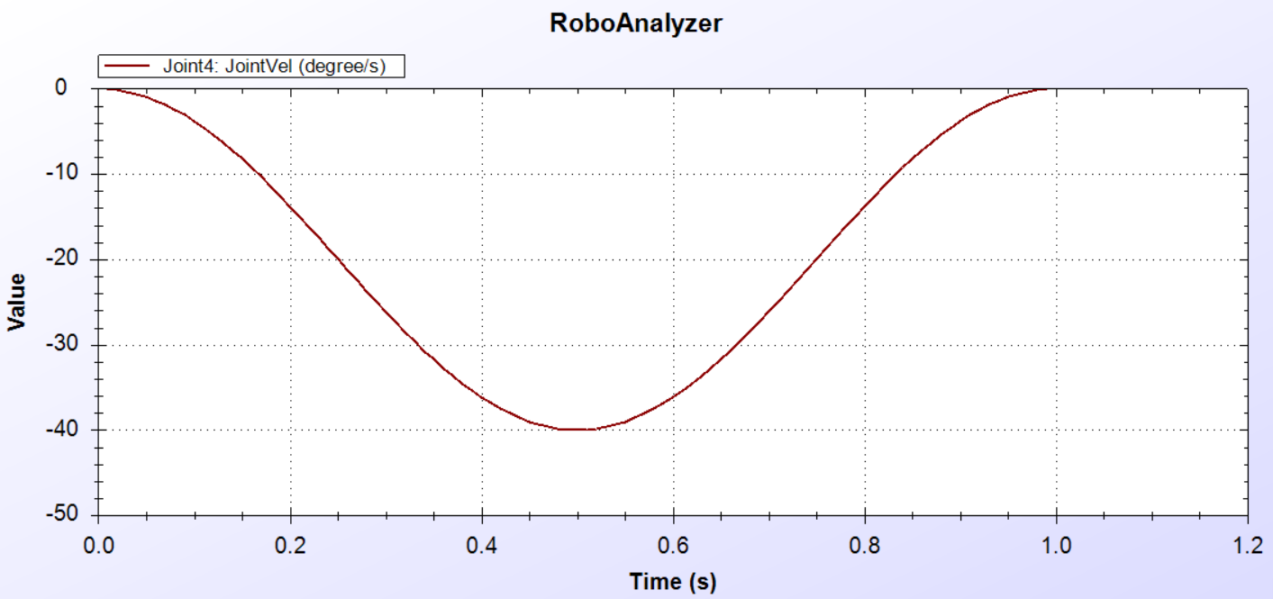

Joint Acceleration – We can see that the value of the joint acceleration is zero at zero seconds whereas it gradually decreases to around -130 °/ second^2 at around 0.25 seconds and then resets to 0 ° at 0.5 seconds, then the value further increases to the value of around 130 °/ second^2 at around 0.75 seconds which then resets to the value of 0 °/second^2 at one second.

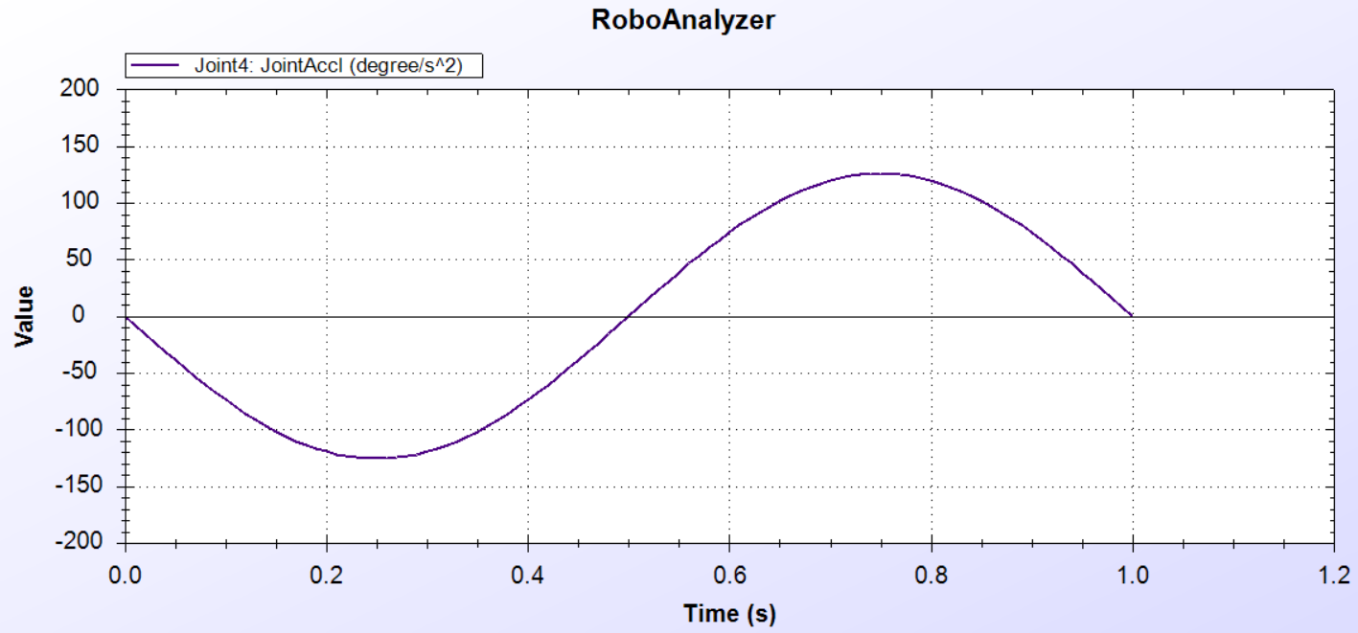

NOTE – No Force/Torq value since we are analyzing a forward kinematics.

For the Joint five the following graphical representation is shown-

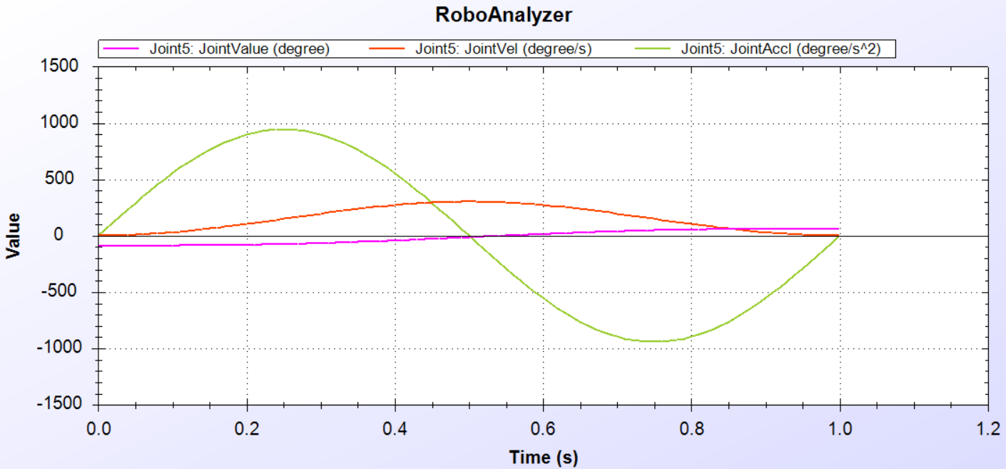

The 5th Joint of the robot has a joint offset of 0 m, a variable joint angle, Link length of 0 m,

Twist angle of 90°, initial value of -90° and a final value of 60°.



The Graphical representation shows the –

Joint Value – We can see that the value of the joint motion is -90 ° at zero seconds whereas it gradually increases to around 60 ° at one second.

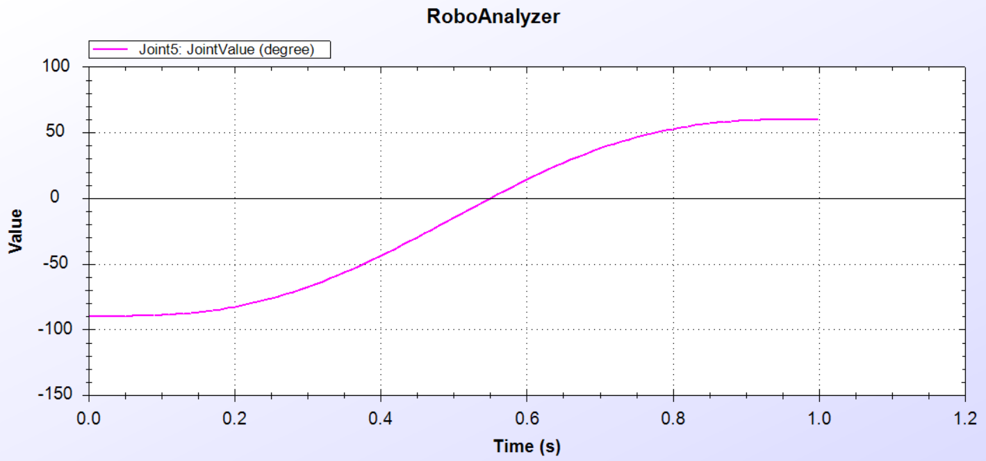

Joint Velocity – We can see that the value of the joint velocity is zero at zero seconds whereas it gradually decreases to around -300 °/second at around 0.5 seconds and then resets to 0 °/second at one second.

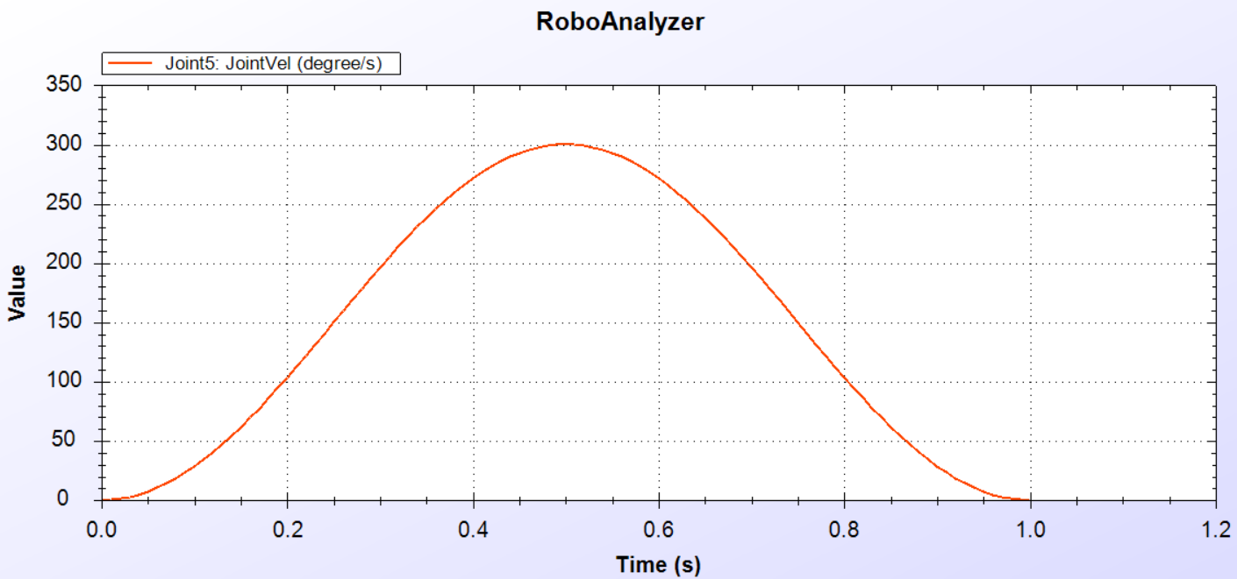

Joint Acceleration – We can see that the value of the joint acceleration is zero at zero seconds whereas it gradually increases to around 900 °/ second^2 at around 0.25 seconds and then resets to 0 ° at 0.5 seconds, then the value further decreases to the value of around -900 °/ second^2 at around 0.75 seconds which then resets to the value of 0 °/second^2 at one second.

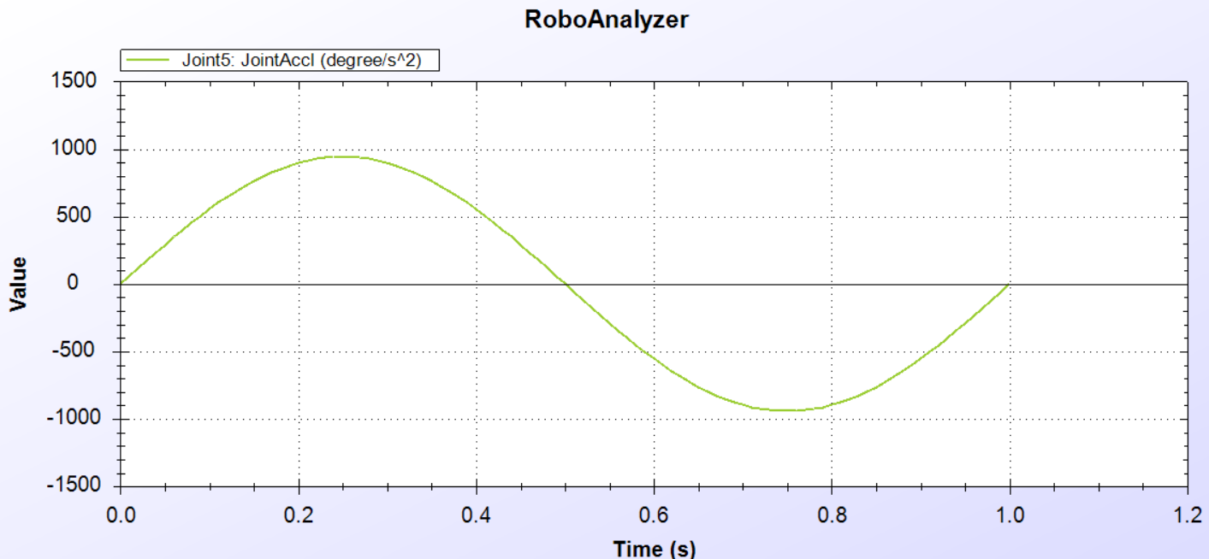

NOTE – No Force/Torq value since we are analyzing a forward kinematics.

The 6th Joint of the robot has a joint offset of 0.063 m, a variable joint angle, Link length of 0 m,

Twist angle of 0°, initial value of 0° and a final value of 60°.



The Graphical representation shows the –

Joint Value – We can see that the value of the joint motion is 0 ° at zero seconds whereas it gradually increases to around 60 ° at one second.

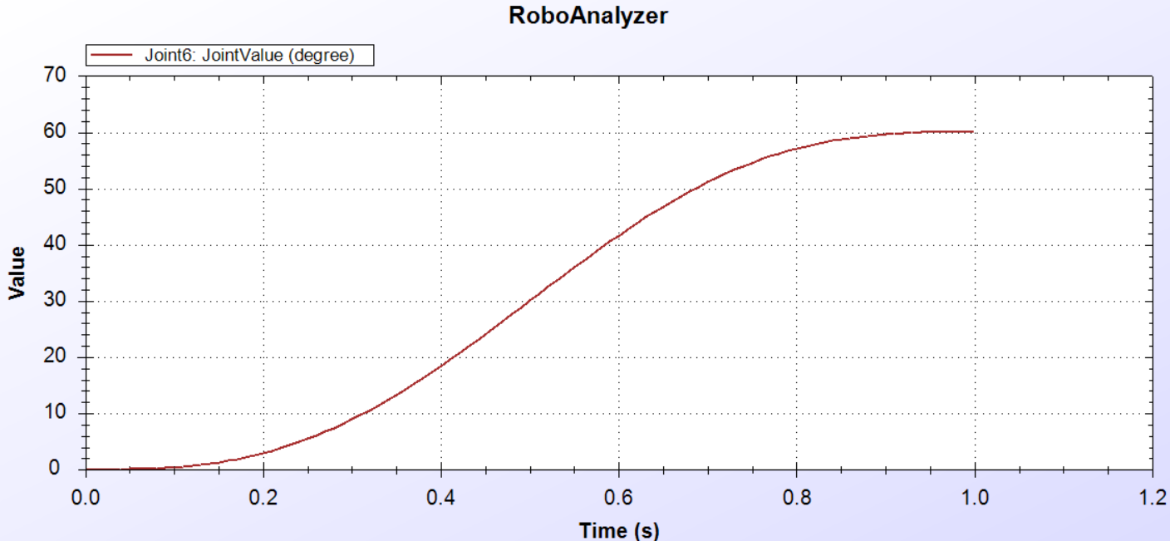

Joint Velocity – We can see that the value of the joint velocity is zero at zero seconds whereas it gradually increases to around 1200 °/second at around 0.5 seconds and then resets to 0 °/second at one second.

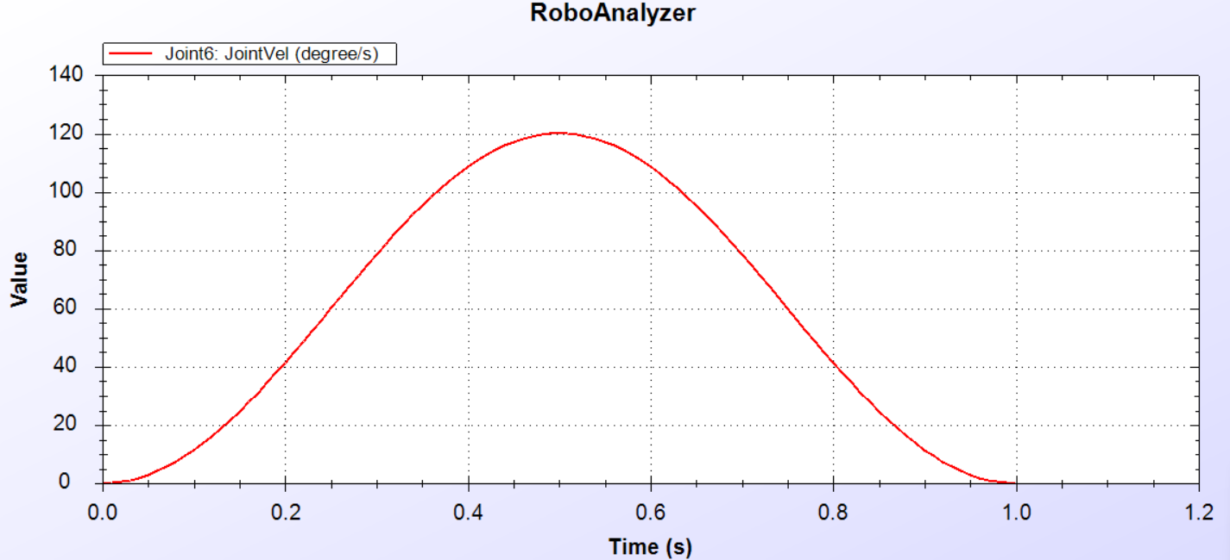

Joint Acceleration – We can see that the value of the joint acceleration is zero at zero seconds whereas it gradually increases to around 380 °/ second^2 at around 0.25 seconds and then resets to 0 ° at 0.5 seconds, then the value further decreases to the value of around -380 °/ second^2 at around 0.75 seconds which then resets to the value of 0 °/second^2 at one second.

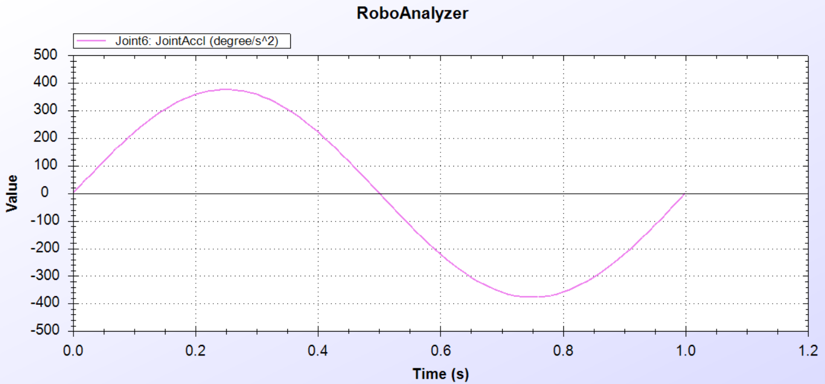

NOTE – No Force/Torq value since we are analyzing a forward kinematics.

Conclusion (Forward Kinematics)

In summary, the analysis of Forward Kinematics offers a comprehensive understanding of the ARISTO robot's movement, leveraging the provided Denavit-Hartenberg (D-H) parameters. By simulating the Forward Kinematics, we gain insights into how the robot positions its end-effector in three-dimensional space. Additionally, this analysis enables us to visualize the movement of the robot's links along the X, Y, and Z axes, providing intuitive graphical representations. Furthermore, we can observe the joint values, velocities, and accelerations of the robot's joints, enhancing our understanding of the dynamic behavior of the system. Overall, this comprehensive analysis aids in designing, controlling, and optimizing the ARISTO robot for various applications, while facilitating diagnostics and improvements to its operational efficiency and effectiveness.

Analysis of Inverse Kinematics

With the completion of the Forward Kinematics analysis, we now transition to exploring Reverse Kinematics. While Forward Kinematics allowed us to understand how the ARISTO Robot's end-effector moves based on given joint configurations, Reverse Kinematics presents the inverse problem: determining the joint angles or displacements required to achieve a desired end-effector pose.

By delving into Reverse Kinematics, we aim to uncover the precise joint configurations necessary to attain specific end-effector positions and orientations. This analysis will further enhance our understanding of the ARISTO Robot's motion capabilities and enable us to develop precise control strategies for achieving desired tasks and trajectories.

Just to revise what is Inverse Kinematics we will read the definition of it once again –

Reverse kinematics is the process of determining the joint angles or displacements required to achieve a desired position and orientation of the end-effector (such as a gripper or tool) of a robotic system.

In essence, Reverse Kinematics involves determining the necessary joint configurations of the ARISTO Robot to achieve a desired orientation of the end effector. This is achieved by providing the software with the final position and orientation of the end effector, allowing it to calculate the corresponding joint angles required to reach that specific pose.

In the analysis of Forward Kinematics, we utilized the position matrix to visualize and understand the evolving positions of the ARISTO Robot's links as it moves. This position matrix serves as a crucial dataset, providing insights into how the robot's configuration changes over time. Importantly, the positional information contained within the matrix lays the foundation for determining the inverse kinematics of the ARISTO Robot. By analyzing the positional data, we can infer the corresponding joint angles or displacements necessary to achieve specific end-effector poses. Thus, the insights gleaned from the Forward Kinematics analysis play a pivotal role in guiding the development and implementation of precise control strategies for the robot's motion through inverse kinematics techniques.

To access the Inverse Kinematics function for the ARISTO Robot in RoboAnalyzer we 1st need to open the Robo Analyzer Software.

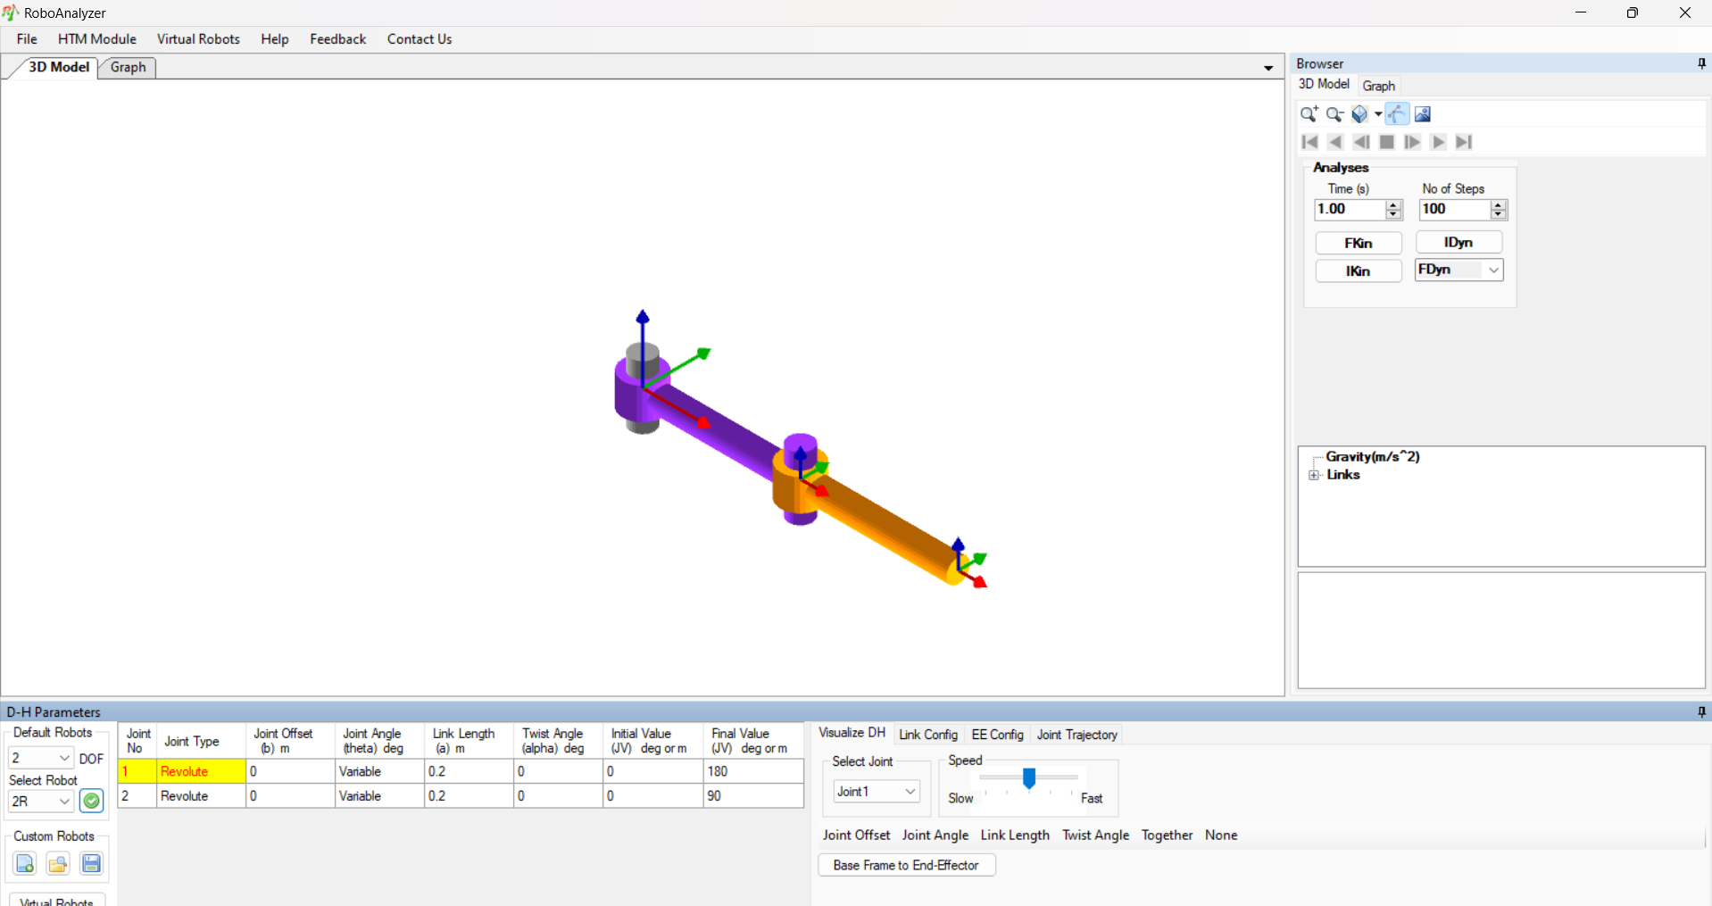

The above screenshot will be the visualization of the software when you open it.

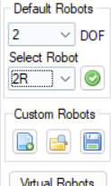 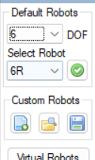

To access the ARISTO Robot, we will again go to the Default Robot option and change the DOF to 6, then change the Select Robot from 6R to ARISTO, then we will click the green tick.

You should now see the following –

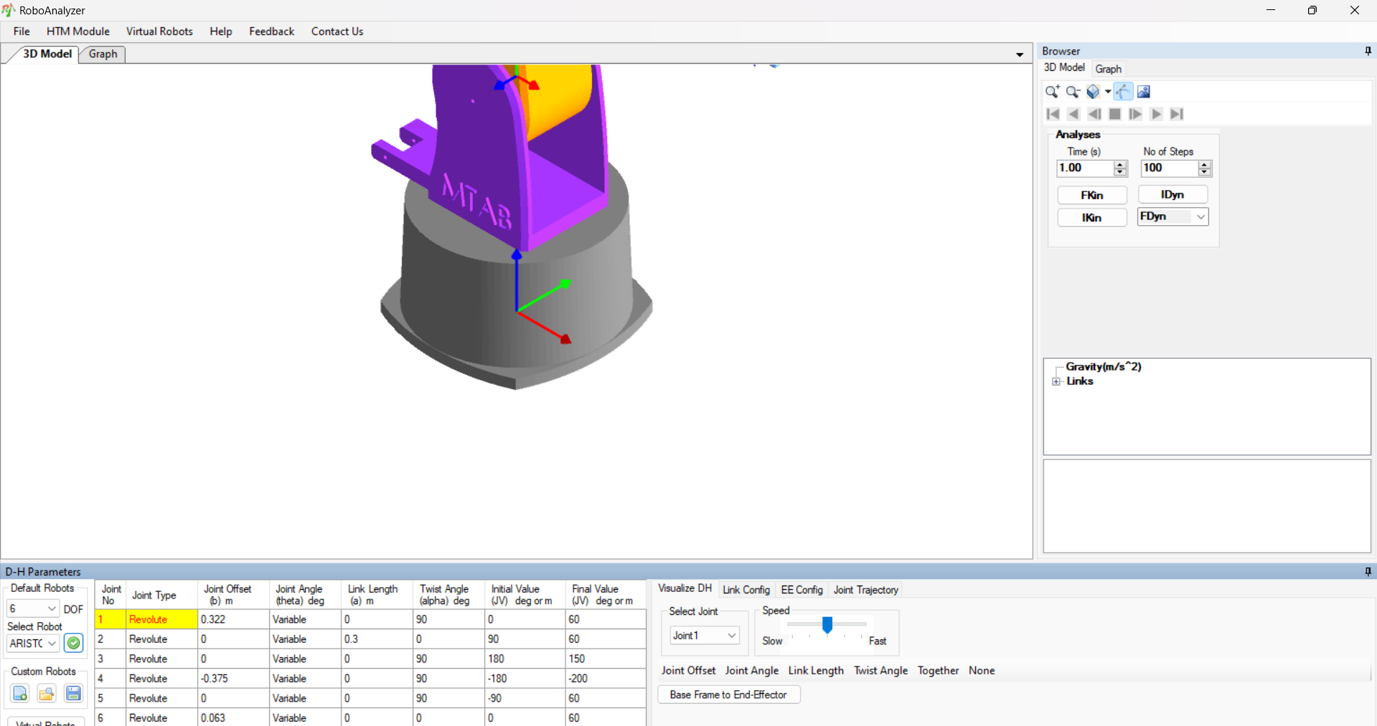

Again, to bring the Robot in frame zoom out using the scroll wheel or the zoom out option from the 3D model tab.

Now to access the Inverse Kinematics instead of clicking the FKin button which we do in the Forward Kinematics, we will be clicking the IKin button for Inverse Kinematics.

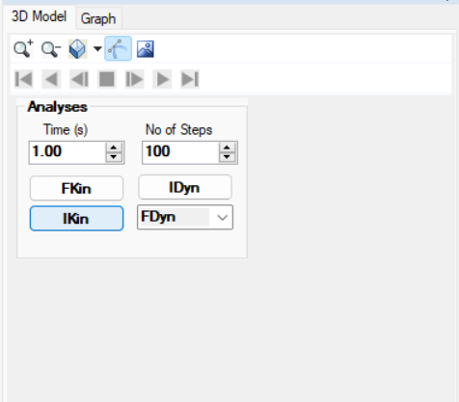

After clicking the IKin button we will see then following popup –

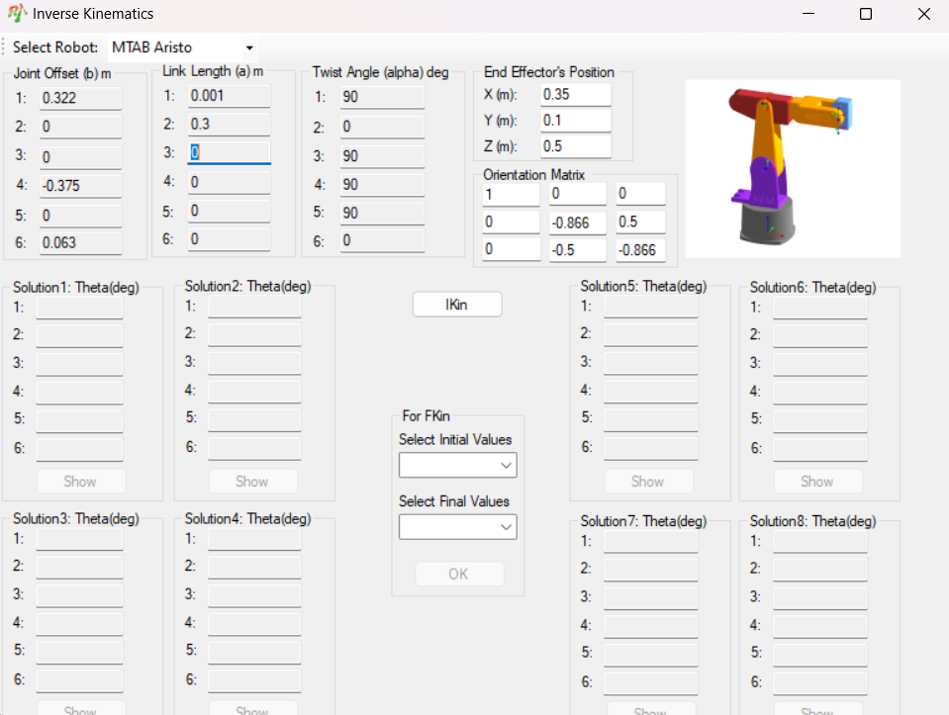

Welcome to the Inverse Kinematics Tab, where we have access to a range of crucial values for understanding and controlling the ARISTO Robot's motion. Here's what you'll find:

1. Joint Offset: Defines the perpendicular distance between consecutive joint axes along their common normal.

2. Link Length: Represents the physical length of each segment connecting adjacent joints in the robotic manipulator.

3. Twist Angle: Specifies the angle of rotation between consecutive links in the robot's structure.

4. End Effector’s Position: Provides the desired final position of the end effector in 3D space.

5. Orientation Matrix:Describes the desired orientation of the end effector using a matrix representation.

6. IKin Button: Initiates the calculation of inverse kinematics solutions based on the provided inputs.

Below the IKin button, you'll find solution tabs (1-8) where the computed inverse kinematics solutions will be displayed once calculated. Currently, these tabs are empty, awaiting the results of the inverse kinematics calculations. This tab serves as a powerful tool for specifying desired end effector poses and computing the corresponding joint configurations required to achieve them. Let's explore further and unlock the full potential of the ARISTO Robot's motion capabilities.

To start with the inverse kinematics, we need to fill the Orientation matrix, the pre filled tabs are the values the software read from the RoboAnalyzer’s D-H parameters.

We cannot fill in random values in the Orientation matrix since the Work Volume of the Aristo Robot is limited, any value outside that region will result in the failing to find the inverse kinematics.

Firstly, we will use the predefined value of the Orientation matrix.

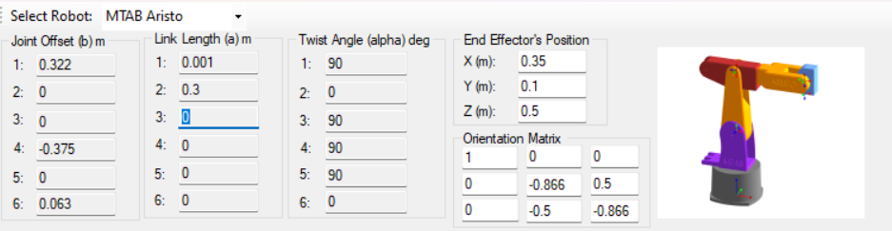

This is the Predefined Value of the Orientation matrix. Clicking on the IKin button will initiate the calculation of the inverse matrix.

The Software uses a specific formula for finding the Solutions for the inverse kinematics.  
  
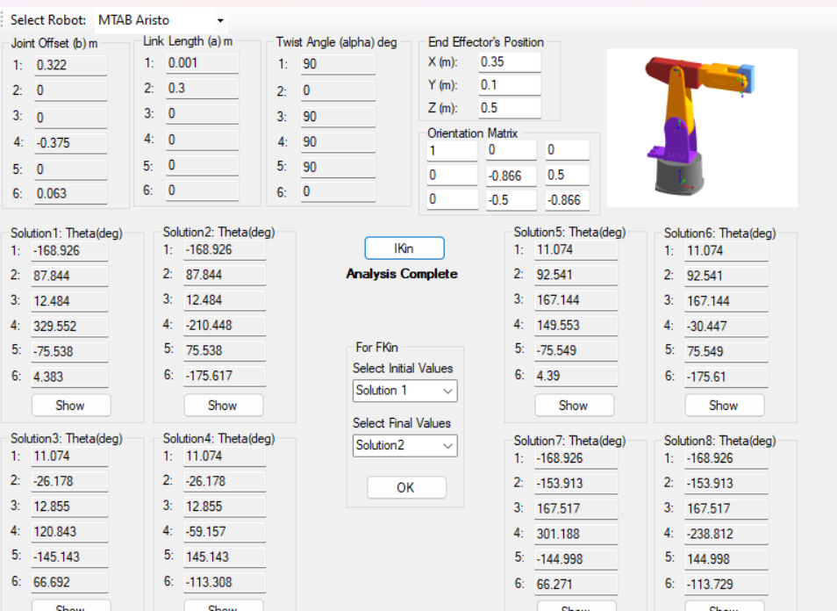

Now that we have clicked on the IKin Button we can see the solution tabs filles w some values , these values are the angles at which each link is kept to find the proper position of the end effector, according to some mathematical calculations there can be only 8 solutions to a specific position of the end effector.

Below the IKin button we can see a tab namd For FKin , this sets the initial and the final values of the Joints for the Forward Kinematics of the ARISTO Robot.

By clicking on the Show Button below each Solution we can see a change in the position of the links and joints of the Aristo Robot to achieve the desired position of the End Effector.

For Solution 1 –

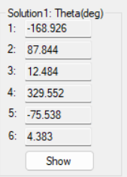 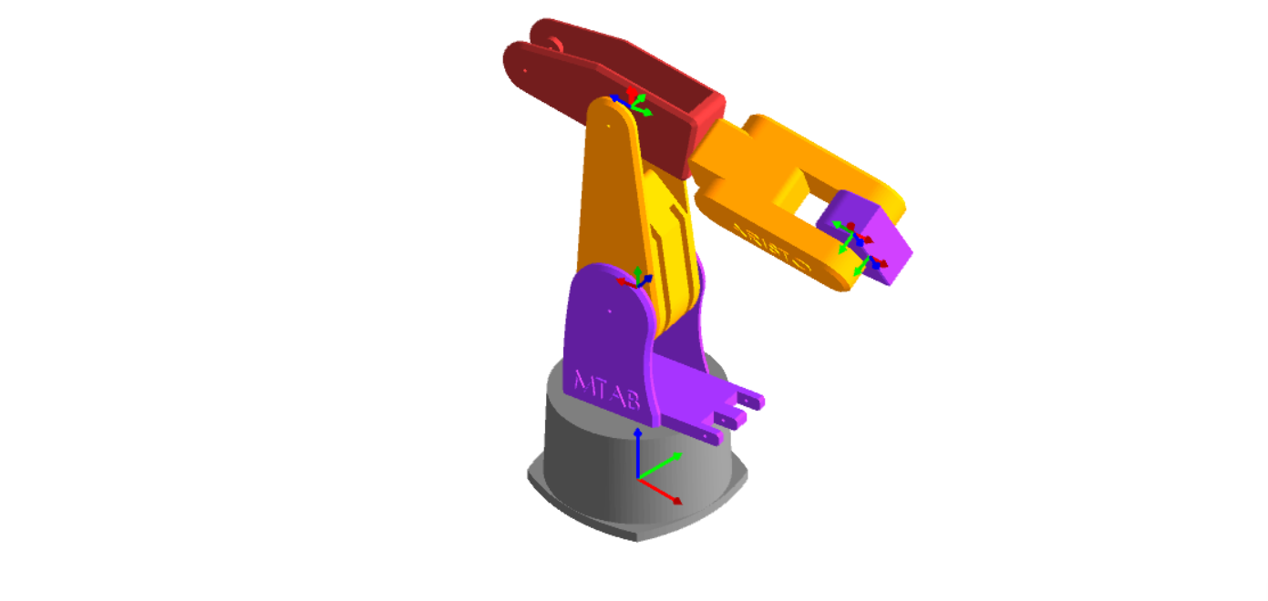

For Solution 2 –

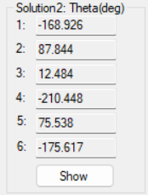 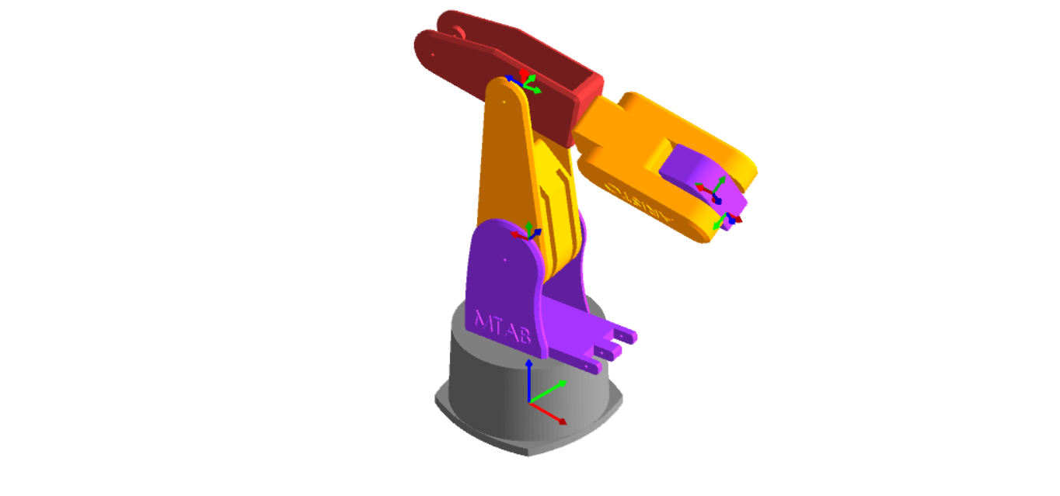

For Solution 3 –

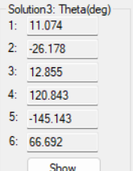 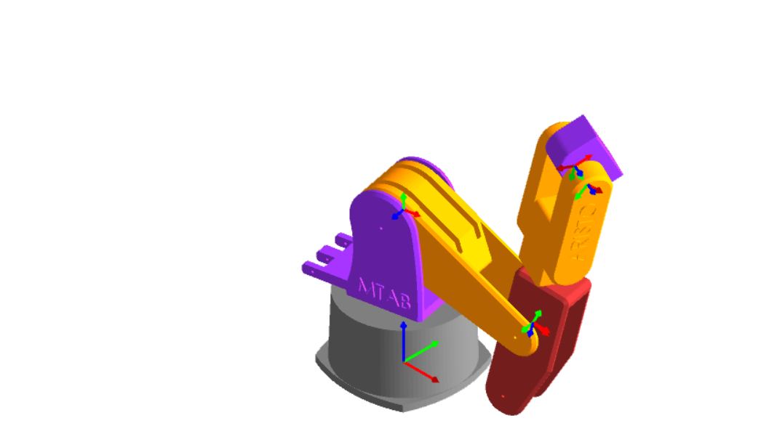

For Solution 4 –

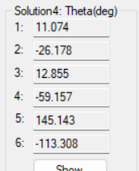 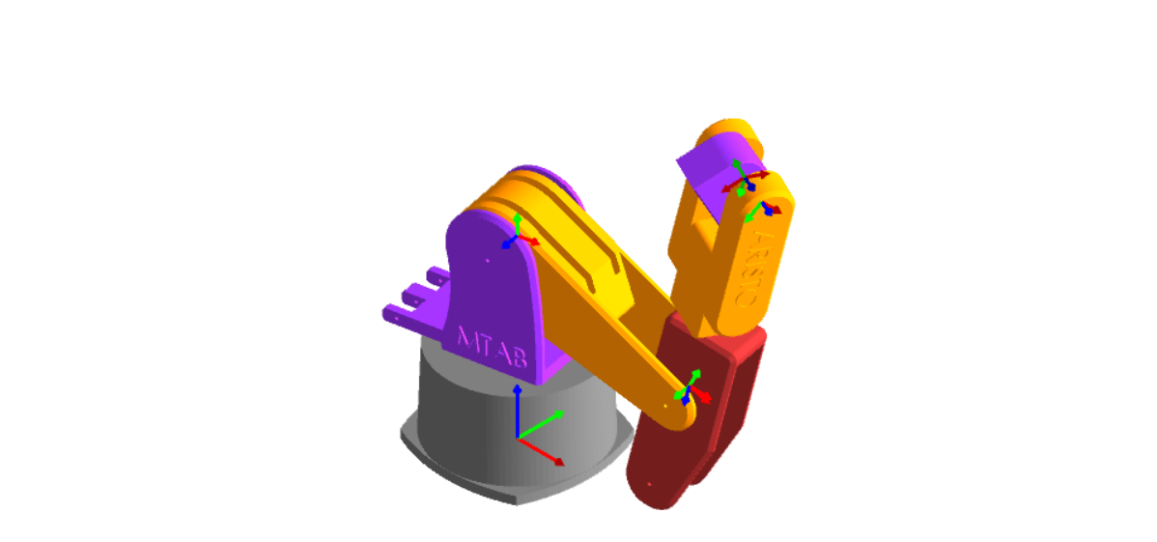

For Solution 5 –

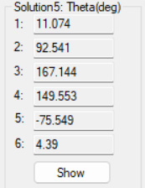 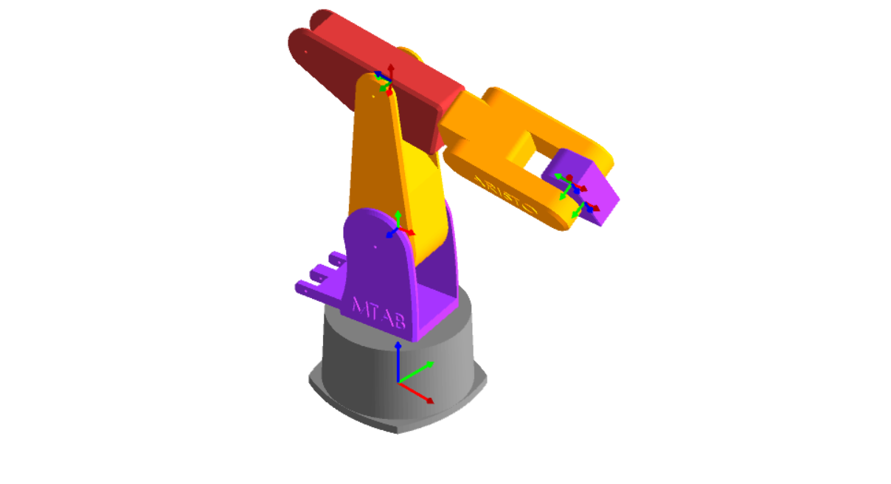

For Solution 6 –

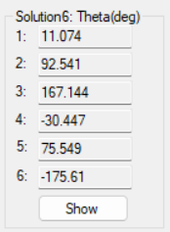 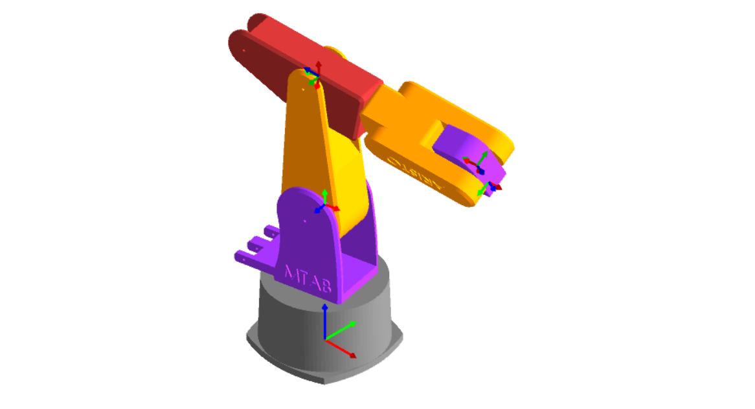

For Solution 7 –

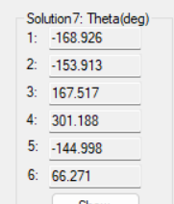 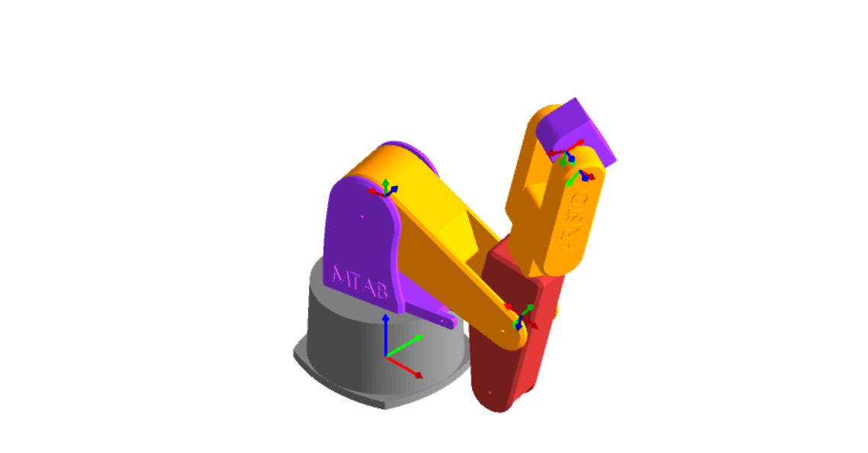

For Solution 8 –

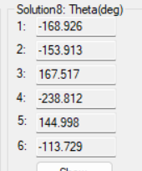 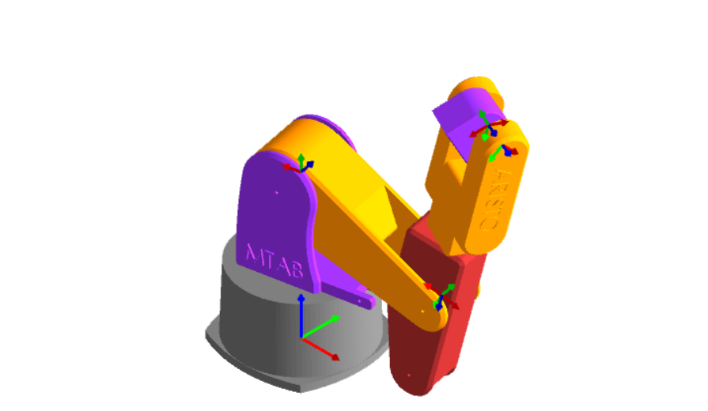

From the above Representation of the Inverse Kinematics of the ARISTO Robot we could clearly see the positions it can have to result in the position of the end effector in the desired position.

Conclusion for the Inverse Kinematics

In the preceding explanation of Inverse Kinematics, we highlighted its utility in determining feasible positions of the ARISTO Robot based on a user-defined valid Orientation Matrix. This functionality extends beyond robotics, finding application in numerous real-life scenarios. For instance:

1. Robotics and Automation: In manufacturing settings, inverse kinematics enables robots to accurately position and manipulate objects based on desired orientations, facilitating tasks such as assembly, pick-and-place operations, and welding.

2. Medical Robotics: In surgical robotics, inverse kinematics is utilized to guide robotic arms during minimally invasive procedures, ensuring precise movements and placements of surgical instruments relative to anatomical structures.

3. Animation and Gaming: In computer graphics and animation, inverse kinematics is employed to create lifelike character animations by determining joint configurations that achieve desired poses and movements.

4. Virtual Reality (VR) and Augmented Reality (AR): In VR and AR applications, inverse kinematics allows for realistic interactions between users and virtual objects or environments, enhancing immersion and user experience.

5. Mechatronics and Control Systems: In mechatronic systems and control engineering, inverse kinematics plays a vital role in designing and controlling robotic manipulators, industrial automation systems, and motion control platforms.

6. Simulation and Training: In simulation environments, inverse kinematics is used to simulate realistic movements of robotic systems for training purposes, allowing operators to practice tasks in a virtual setting before executing them in real-world scenarios.

7. Artificial Intelligence and Robotics Research: In robotics research and AI development, inverse kinematics is employed to study and develop advanced motion planning algorithms, enabling robots to navigate complex environments and perform intricate tasks autonomously.

By leveraging the principles of inverse kinematics, engineers, researchers, and developers across various domains can solve complex positioning and motion control problems, advancing technology and innovation in diverse fields.

Conclusion

To conclude this project, we explored the Kinematics of the ARISTO Robot which provided us with a comprehensive understanding of RoboAnalyzer – its functionality, graphical representation capabilities, and the significance of various kinematic analyses. Throughout our analysis, we delved into the different types of kinematics, their functions, and definitions, elucidating their roles in understanding and controlling the robot's motion. Importantly, we didn't merely rely on visual 3D models; we also harnessed graphical representations using the graph function. This approach allowed us to vividly depict the motion of both the Links and the Joints, providing deeper insights into the robot's behavior. Through this multifaceted analysis, we've gained valuable insights into the workings of the ARISTO Robot and expanded our knowledge of kinematics in robotics.